

American International University-Bangladesh

**Course Name:** Advanced Database Management System

**Section:** B

**Department:** Computer Science and Engineering

**Submission Date:** August 28, 2023

**Project Name:** Course Registration Management System

**Submitted By:**

|  |  |  |  |
| --- | --- | --- | --- |
| Name | ID | Contribution | Percentage |
| Zuhair Ahmed | 20-42115-1 | Interface Design and Description, Schema Diagram, Table Creation, Data Insertion, Query Writing | 25% |
| Nabila Chowdhury Joya | 20-42268-1 | Scenario Description, ER Diagram, Normalization, Table Creation, Query Writing | 25% |
| Amit Podder | 20-42273-1 | Class Diagram, Use Case Diagram, Activity Diagram, Table Creation, Data Insertion, Normalization, Query Writing | 25% |
| Md. Forhadul Islam | 20-42091-1 | Normalization, Data Insertion, Query Writing, Relational Algebra | 25% |

**Submitted To:**

**JUENA AHMED NOSHIN**

Assistant Professor, Computer Science

Table of Contents

**Introduction ................................................................................................................................ 3**

**Project Proposal .......................................................................................................................... 3**

**Class Diagram ............................................................................................................................. 3**

**Use Case Diagram ...................................................................................................................... 4**

**Activity Diagram ........................................................................................................................ 5**

**Interface Design and Description.............................................................................................. 6**

**Scenario Description ................................................................................................................ 10**

**ER Diagram .............................................................................................................................. 11**

**Normalization ........................................................................................................................... 12**

**Schema Diagram ...................................................................................................................... 17**

**Table Creation .......................................................................................................................... 18**

**Data Insertion ........................................................................................................................... 29**

**Query Writing………………………………………………………………………………... 37**

**Relational Algebra ................................................................................................................... 68**

**Conclusion ................................................................................................................................ 68**

**Introduction:**

A course registration management system is a software application designed to manage the process of student registration for courses offered by educational institutions. The system will provide a platform for students to view course offerings, select courses, register for courses, and manage their registration status. The system will also provide the Department with tools to manage course offerings, student registration, and student enrolment data.

**Project Proposal:**

The course registration management system is a software application that will manage the registration process for students at educational institutes. This software will provide a user-friendly interface for students to view and select courses they will take. As well as allow administrative staff to access course offerings, student enrollment, and other related stuff. The faculty taking courses will also have the option to enroll at their preferred times and schedules. The course management system will be implemented using a combination of programming languages, database management systems, and web technologies. The specific tools and technologies used will depend on the requirements and preferences of the institute.

**Class Diagram:**

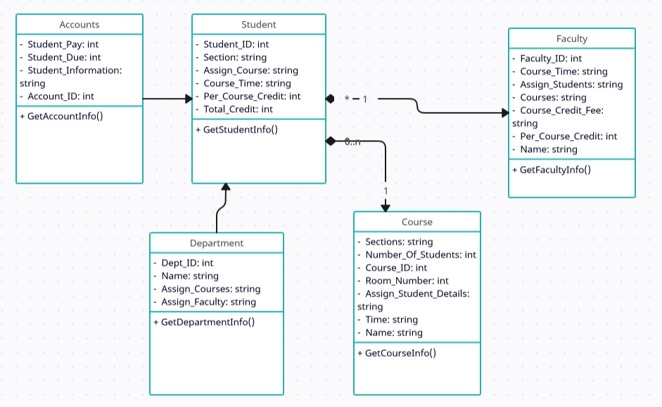

**Use Case Diagram:**

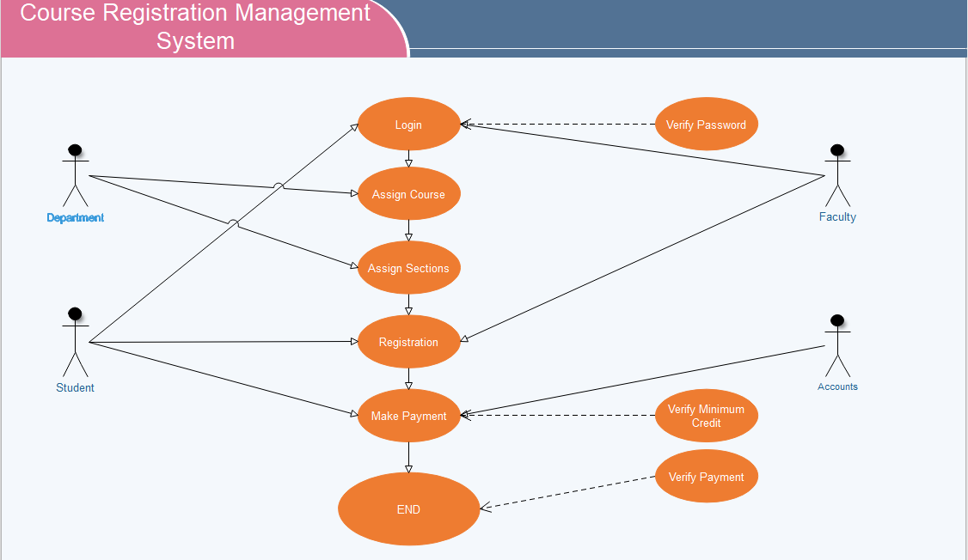

**Activity Diagram:**

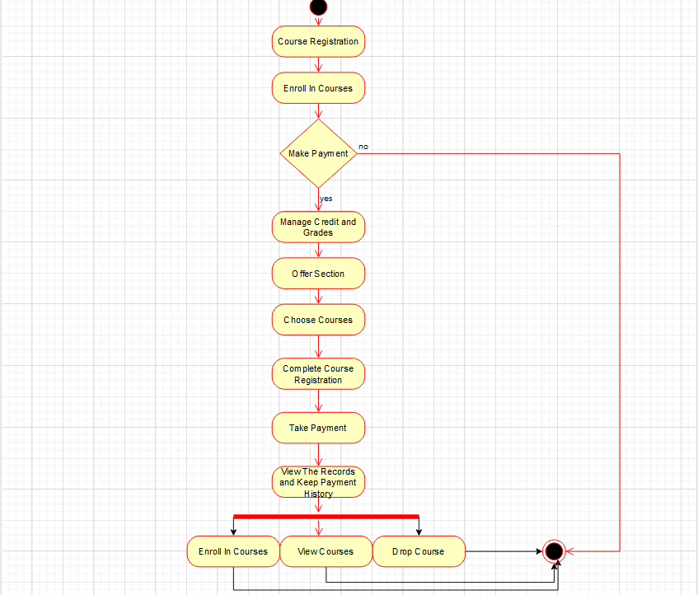

**Interface Design and Description:**

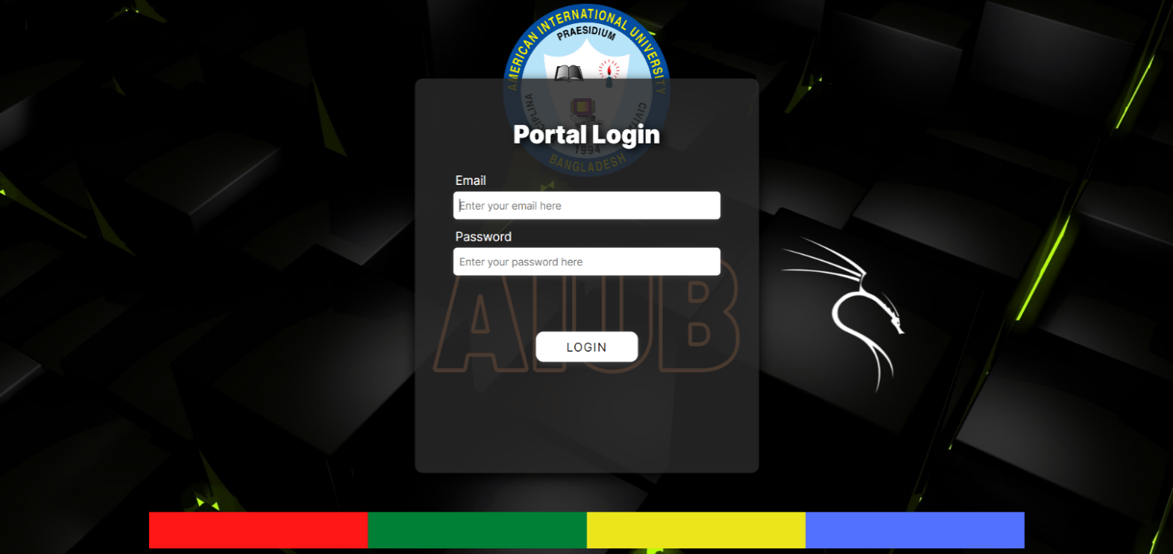

Figure 01: Portal Login

If the user is a student or faculty member, they will have access to a dedicated portal. This portal will automatically detect whether the user is a student or faculty member.



Figure 02: Faculty Dashboard

The Faculty Dashboard includes four buttons and a logout button. The “Add Course” button enables faculty to add new courses, while the “Delete Course” button is used to remove courses that are no longer offered, and “Update Course” is for new times or section updates. The section list displays the number of available sections and is not visible to students. Refer to [Figure: 06] for an interface view. Faculty members can log out at any time by clicking the "Logout" button.

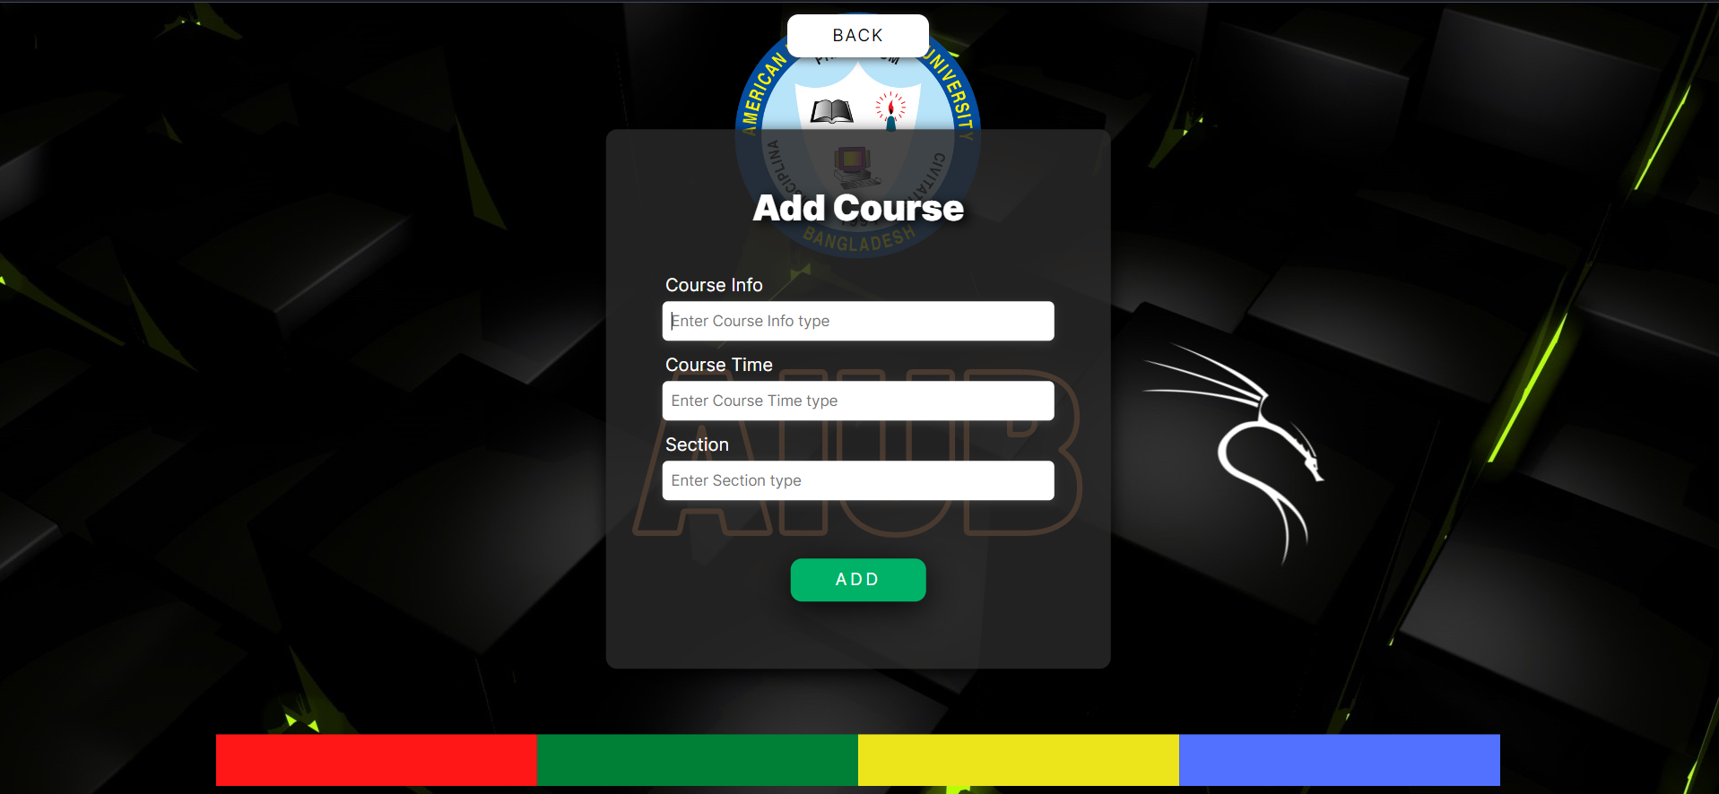

Figure 03: Add Course

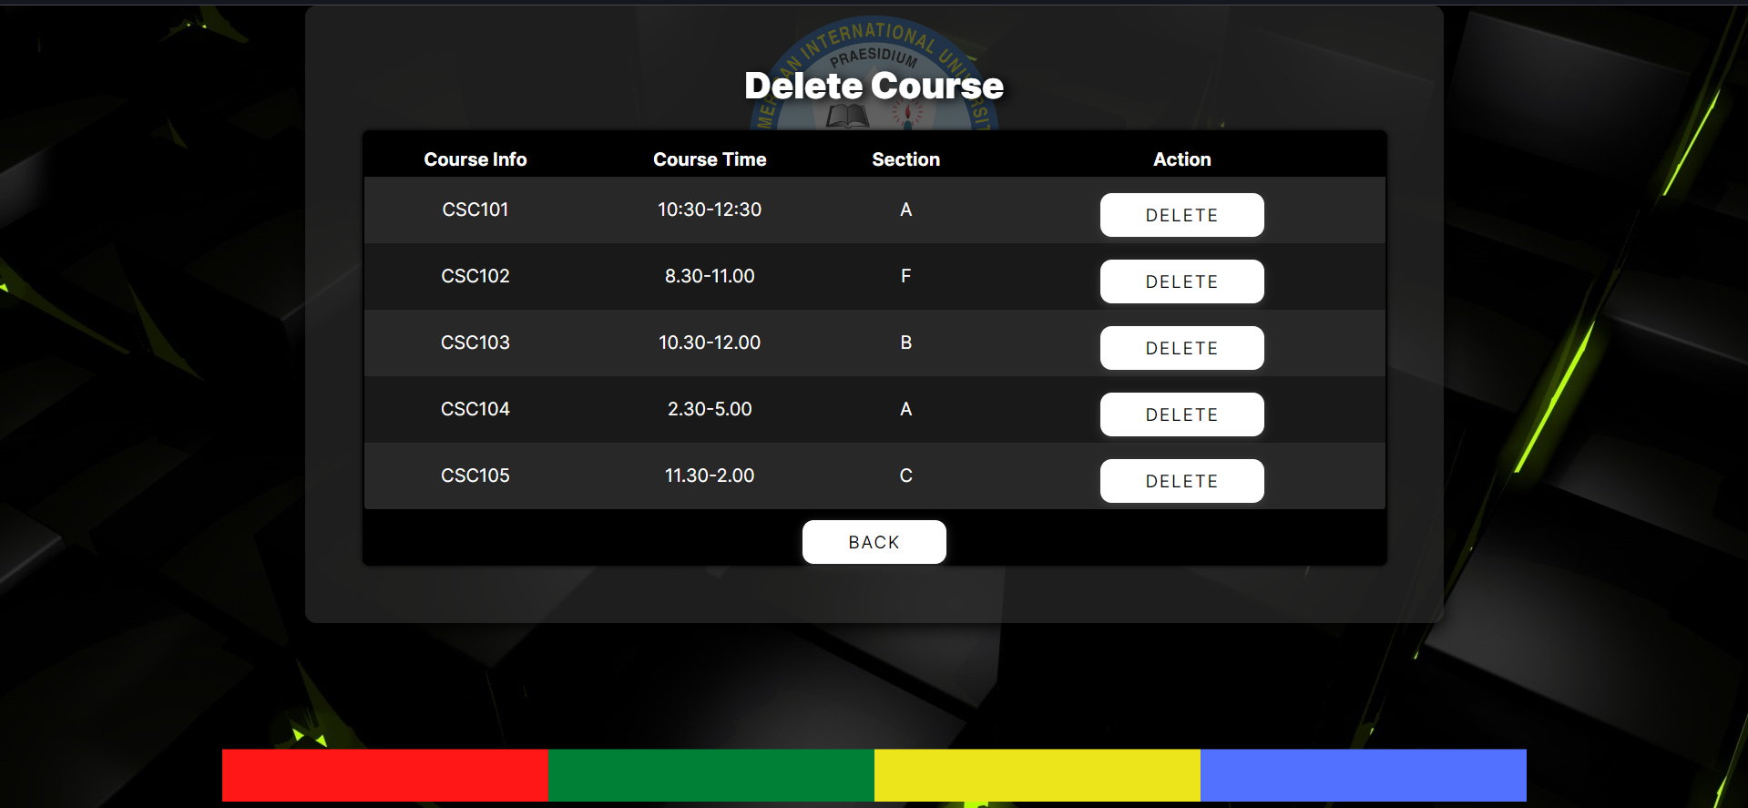

Figure 04: Delete Course

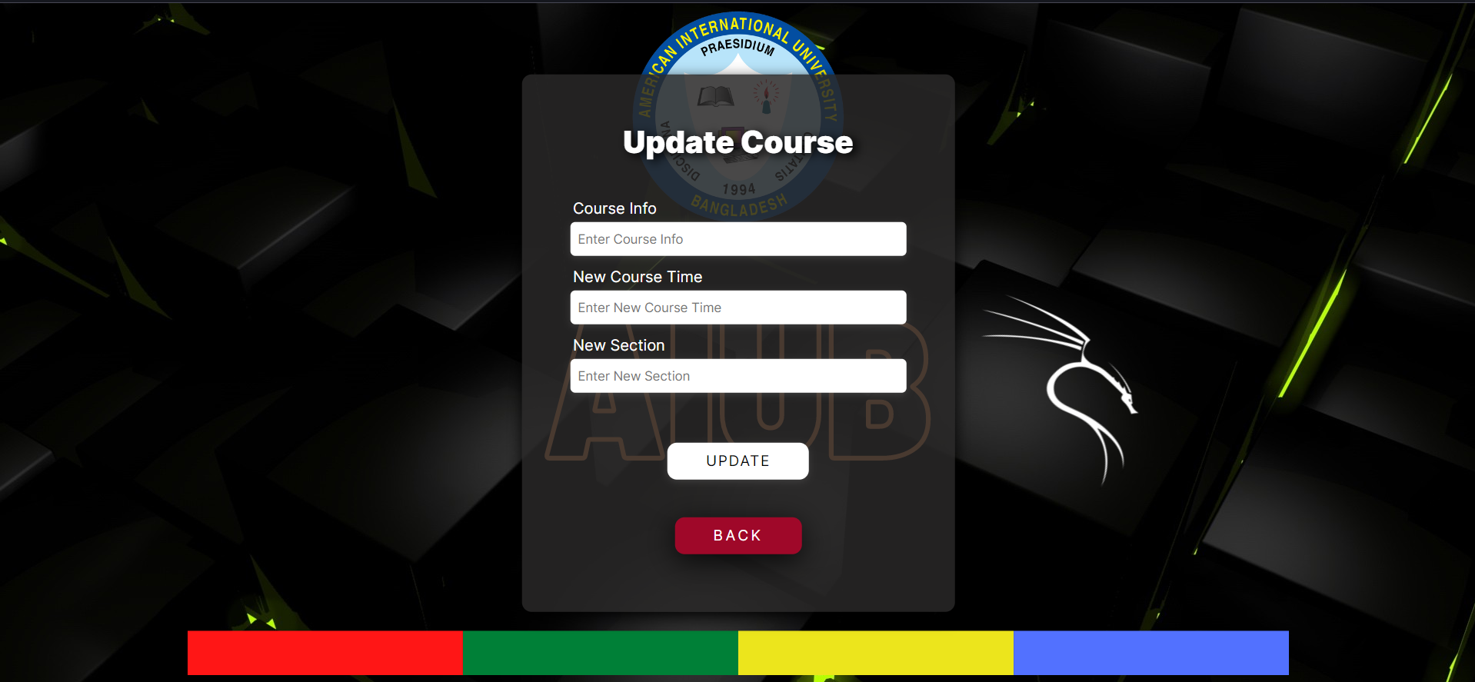

Figure 05: Update Course

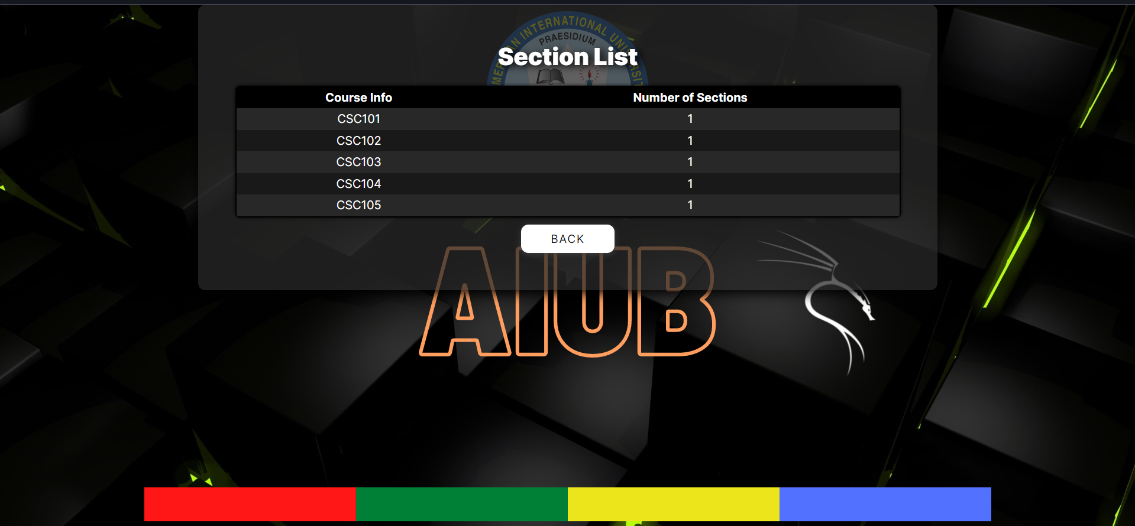

Figure 06: Section List

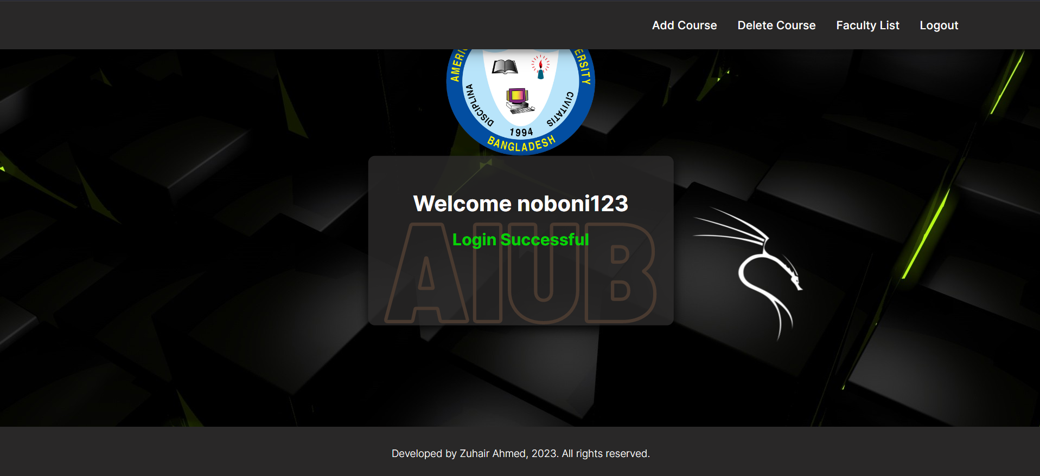

Figure 07: Student Dashboard

The student dashboard will display a welcome message with the student's username. To enroll in a course, the student can click "Add Course". If a course is deleted, the student can view it in the "Delete Course" section. If they wish to re-enroll in a previously deleted course, a fine will be imposed. The faculty list will display the departments of the course faculties. Students can log out at any time by clicking "Logout".

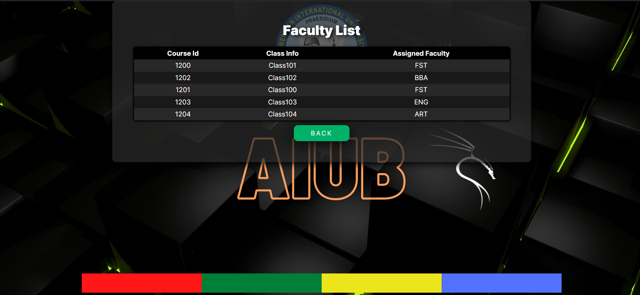

Figure 08: Faculty List

**Scenario Description:**

In a university, a Course Management System has been established to efficiently manage various aspects of student enrollment, course assignments, faculty responsibilities, and financial transactions. The system is built upon a robust relational database structure, enabling seamless interactions between different components. The university's lifeblood, each student is uniquely identified by an "S_info" and is associated with personal details, including name, username, password, and email. Students are assigned to classes and are enrolled in courses based on their academic department. Courses are the building blocks of education, identified by "Course_info." Each course has associated details like its schedule "Course_time" and class section "SECTION". They also have specific credit requirements and fees, outlined in the "DetailsCourse". Faculty members are responsible for teaching courses, managing student assignments, and handling various academic tasks. They are identified by a unique "Faculty_id" and have a username, password, and email for system access. Faculty members are assigned to specific courses and oversee a group of students. Classes represent physical spaces where courses are conducted. Each class is identified by "Class_info" and has a room number and section information. Academic departments are responsible for managing specific sets of courses and students. Each department is identified by a "Department_id" and is associated with faculty, courses, and students. Financial transactions are recorded in the "Transaction" section. Each transaction is uniquely identified by "S_transaction" and is related to a student's payment and due amounts. Accountants manage the financial records of students. They are identified by "Accountant_id" and are associated with student information, transactions, students' IDs, and course information. There will be also a table containing detailed information about students, including their assigned courses, credit requirements, and course-related details. Each student is identified by a unique "Students_id" and has links to courses, classes, and academic departments. Also, a table contains additional details about courses, such as the assigned faculty, class information, and more. Each course is identified by "Course_id" and is linked to its related faculty, class, and course details.

**ER Diagram:**

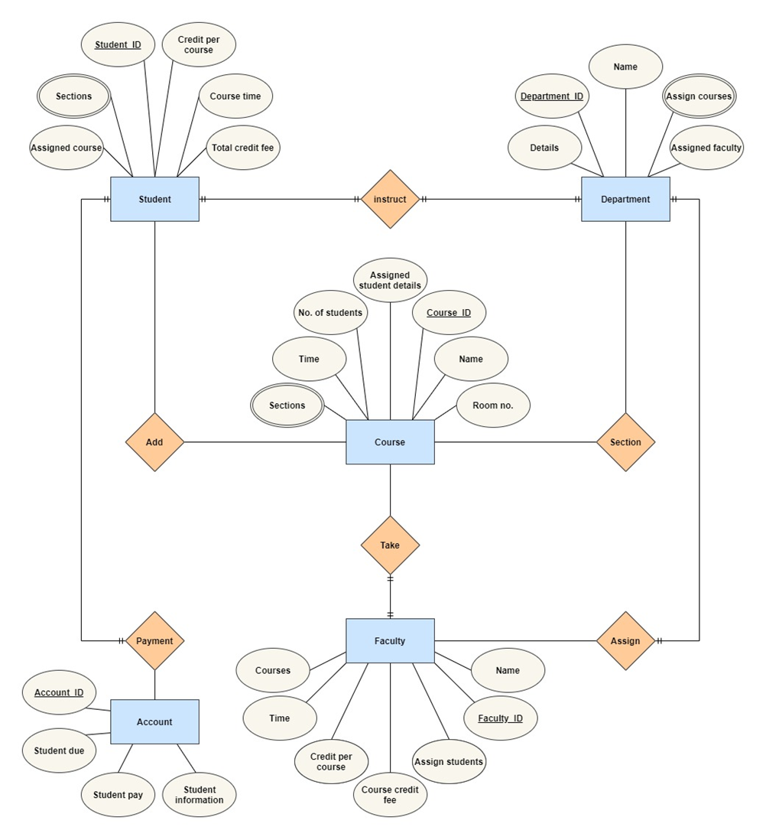

**Normalization:**

**Payment-** Accountant_id,Students_pay, Students_due, Students_information, Assign_Course, Sections, Credit_per_course, Studnets_id, Course_time, total_credit_fee

1NF- Sections are multivalued attributes.

Accountant_id , Students_pay, Students_due, Students_information,

Assign_Course, Sections, Credit_per_course, Studnets_id, Course_time,

total_credit_fee

2NF-

Accountant_id, Students_pay, Students_due, Students_information

Studnets_id, Assign_Course, Sections, Credit_per_course, Course_time,

total_credit_fee

3NF-

Accountant_id, Students information.

S_transaction, Students_pay, Students_due.

Studnets_id, Assign Course, Credit per course, total credit fee.

Course_info, Sections, Course time.

Final Table-

1. Accountant_id, Students information, S_transaction, Studnets_id, Course_info.
2. S_transaction, Students_pay, Students_due.
3. Studnets_id, Assign Course, Credit per course, total credit fee.
4. Course_info, Sections, Course time.

**Instruct-** Assign_Course, Sections, Credit per course, Students_id, Course time, total credit fee, Details, Department_id, Name, Assigned_courses, Assigned faculty.

1NF- Sections and Assigned Courses are multivalued attributes.

Studnets_id, Assign Course, Sections, Credit per course, Course time, total credit fee, Details, Department_id, Name, Assigned courses, Assigned faculty.

2NF-

Studnets_id, Assign_Course, Sections, Credit per course, Course time,

total_credit_fee.

Department_id, Assigned_courses, Details, Name, Assigned faculty.

3NF-

Studnets_id, Assign Course, Credit per course, total credit fee.

Course_info, Sections, Course time.

Department_id,Assigned_courses,Assigned_faculty. S_info,_Details, Name.

Final Table-

1. Studnets_id, Assign Course, Credit per course, total credit fee, Course_info, Department_id, S_info.
2. Course_info, Sections, Course time.
3. Department_id, Assigned course, Assigned faculty.
4. S_info, Details, Name.

**Add-** Assign Course, Sections, Credit per course, Students_id, Course time, total credit fee, Sections, time, Number of students, assigned student details, Course_id, Name, Room number.

1NF- Sections are multivalued attributed.

Assign Course, Sections, Credit per course, Students_id, Course time, total credit fee, sections, time, Number of students, assigned student details, Course_id, Name, Room number.

2NF-

Students_id, Assign Course, Sections, Credit per course, Course time, total credit fee.

Course_id, Sections, time, Number of students, assigned student details, Name, Room number.

3NF-

Studnets_id, Assign Course, Credit per course, total credit fee.

Course_info, Sections, Course time.

Course_id, time, Number of students, assigned student details, Name.

Class_info, Sections, room number.

Final Table-

1. Studnets_id, Assign Course, Credit per course, total credit fee, Course_info, Course_id, Class_info,
2. Course_info, Sections, Course time.
3. Course_id, time, Number of students, assigned student details, Name.
4. Class_info, Sections, room number.

**Take-** Sections, time, Number of students, assigned student details, Course_id, Name, Room number, Courses, time, credit per course, Course credit fee, assigned students, Faculty_id, Name.

1NF- Sections and courses are multivalued attribute.

Sections, time, Number_of_students, assigned_student_details, Course_id, Name, Room number, Courses, time, credit per course, Course credit fee, assigned students, Faculty_id, Name.

2NF-

Course_id, Sections, time, Number of students, assigned student details, Name, Room number.

Faculty_id, Courses, time, credit per course, Course credit fee, assigned students, Name.

3NF-

Course_id, time, Number of students, assigned student details, Name.

Class_info, Sections, room number.

Faculty_id, Courses, time, assigned students, Name.

Course_d, credit per course, Course credit fee.

Final Table-

1. Course_id, time, Number of students, assigned student details, Name, Class_info, Faculty_id, Course_d,
2. Class_info, Sections, room number.
3. Faculty_id, Courses, time, assigned students, Name.
4. Course_d, credit per course, Course credit fee.

**Section-** Details, Department_id, Name, Assigned courses, Assigned faculty, Sections, time, Number of students, assigned student details, Course_id, Name, Room number.

1NF- Assigned courses and sections are multivalued attribute.

Details, Department_id, Name, Assigned faculty, Sections, time, Number of students, assigned student details, Course_id, Name, Room number.

2NF-

Department_id, Details, Name, Assigned courses, Assigned faculty.

Course_id, Sections, time, Number of students, assigned student details, Name, Room number.

3NF-

Department_id, Assigned course, Assigned faculty.

S_info, Details, Name.

Course_id, time, Number of students, assigned student details, Name.

Class_info, Sections, room number.

Final Table-

1. Department_id, Assigned course, Assigned faculty, s_info, course_id, class_info
2. S_info, Details, Name.
3. Course_id, time, Number of students, assigned student details, Name.
4. Class_info, Sections, room number.

**Assign-** Details, Department_id, Name, Assigned courses, Assigned faculty, Courses, time, credit per course, Course credit fee, assigned students, Faculty_id, Name.

1NF- Assigned Courses and courses are multivalued attributes.

Details, Department_id, Name, Assigned courses, Assigned faculty, Courses, time, credit per course, Course credit fee, assigned students, Faculty_id, Name.

2NF-

Department_id, Details, Name, Assigned courses, Assigned faculty.

Faculty_id, Courses, time, credit per course, Course credit fee, assigned students, Name.

3NF-

Department_id, Assigned course, Assigned faculty.

S_info, Details, Name.

Faculty_id, Courses, time, assigned students, Name.

Course_d, credit per course, Course credit fee.

Final table-

1. Department_id, Assigned course, Assigned faculty, s_info, faculty_id, course_d
2. S_info, Details, Name.
3. Faculty_id, Courses, time, assigned students, Name.
4. Course_d, credit per course, Course credit fee.

**Table after normalization**

1. Accountant_id, Students information, **S_transaction, Studnets_id, Course_info**
2. S_transaction, Students_pay, Students_due
3. Studnets_id, Assign Course, Credit per course, total credit fee
4. Course_info, Course time
5. Course_info, Sections **-Composite PK**
6. Studnets_id, Assign Course, Credit per course, total credit fee, **Course_info,**

**Department_id, S_info**

1. Course_info, Course time
2. Course_info, Sections **-Composite PK**
3. Department_id, Assigned faculty
4. Department_id, Assigned course **-Composite PK**
5. S_info, Details, Name
6. Studnets_id, Assign Course, Credit per course, total credit fee, **Course_info, Course_id, Class_info**
7. Course_info, Course time
8. Course_info, Sections **-Composite PK**
9. Course_id, time, Number of students, assigned student details, Name
10. Class_info, room_number
11. Class_info, Sections **-Composite PK**
12. Course_id, time, Number of students, assigned student details, Name, **Class_info, Faculty_id, Course_d**
13. Class_info, room_number
14. Class_info, Sections **-Composite PK**
15. Faculty_id, Courses, time, assigned students, Name
16. Course_d, credit per course, Course credit fee
17. Department_id, Assigned faculty, **s_info, course_id, class_info**
18. Department_id, Assigned course **-Composite PK**
19. S_info, Details, Name
20. Course_id, time, Number of students, assigned student details, Name
21. Class_info, room number
22. Class_info, Sections **-Composite PK**
23. Department_id, Assigned faculty, **s_info, faculty_id, course_d**
24. Department_id, Assigned course **-Composite PK**
25. S_info, Details, Name
26. Faculty_id, Courses, time, assigned students, Name
27. Course_d, credit per course, Course credit fee

**After removing repetition final tables are**

1. Accountant_id, Students information, **S_transaction, Studnets_id, Course_info**
2. S_transaction, Students_pay, Students_due
3. Studnets_id, Assign Course, Credit per course, total credit fee, **Course_info,**

**Department_id, S_info, Course_id, Class_info**

1. Course_info, Course time, Sections
2. Department_id, Assigned faculty, Assigned_courses, **s_info, course_id, class_info, faculty_id, course_d**
3. S_info, Details, Name
4. Course_id, time, Number of students, assigned student details, Name, **Class_info, Faculty_id, Course_d**
5. Class_info, room number, Sections
6. Faculty_id, Courses, time, assigned students, Name
7. Course_d, credit per course, Course credit fee

**Schema Diagram:**

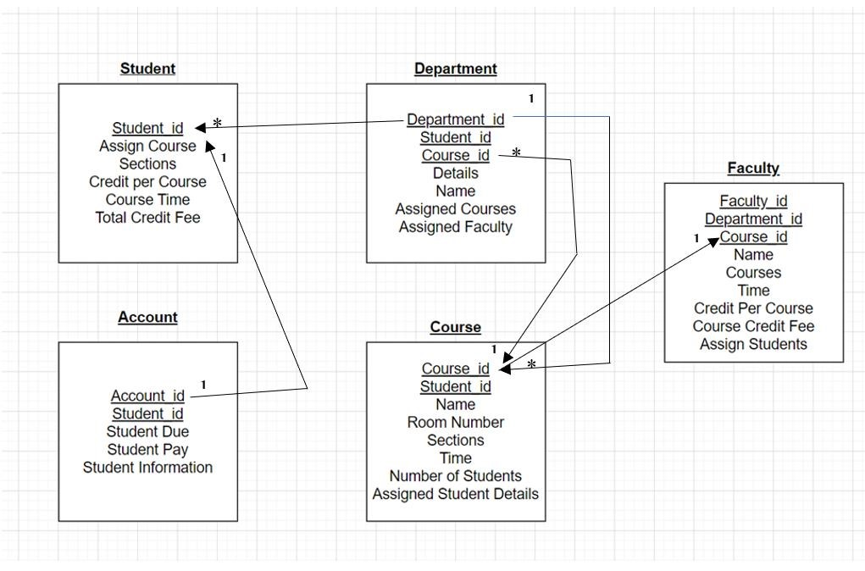

**Table Creation:**

**Create User and Giving Permissions**

CREATE USER ADMS IDENTIFIED BY "tiger";

GRANT CREATE VIEW, CONNECT, RESOURCE, CREATE SESSION, UNLIMITED TABLESPACE TO ADMS;

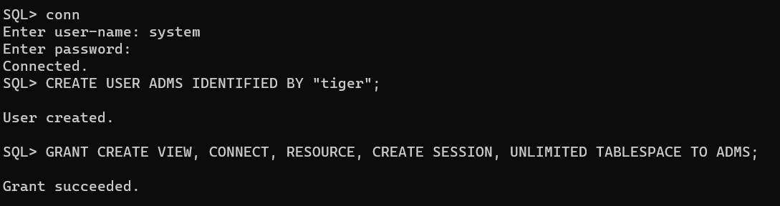

**Transaction Table**

CREATE TABLE Transaction (

S_transaction NUMBER(10) CONSTRAINT pk_trns PRIMARY KEY,

Student_pay NUMBER(10),

Student_due NUMBER(10)

);

CREATE SEQUENCE Transaction_seq

START WITH 1200

INCREMENT BY 1

MAXVALUE 4000

NOCYCLE

NOCACHE;

CREATE INDEX Transaction_indx ON Transaction(S_transaction, Student_pay, Student_due);

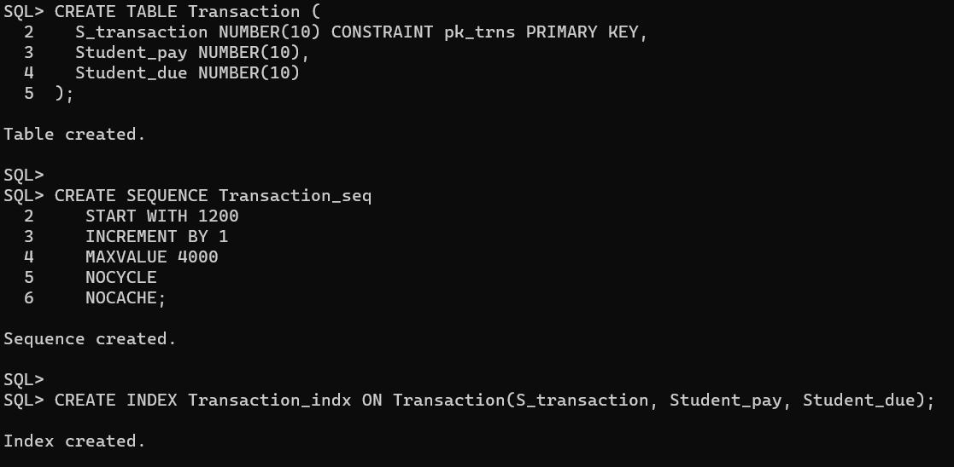

**Table Course**

CREATE TABLE Course (

Course_info VARCHAR2(20) CONSTRAINT pk_Crs PRIMARY KEY,

Course_time VARCHAR2(4),

Section VARCHAR2(8)

);

CREATE SEQUENCE Course_seq

START WITH 1100

INCREMENT BY 1

MAXVALUE 3000

NOCYCLE

NOCACHE;

CREATE INDEX Course_indx ON Course(Course_info, Course_time, Section);

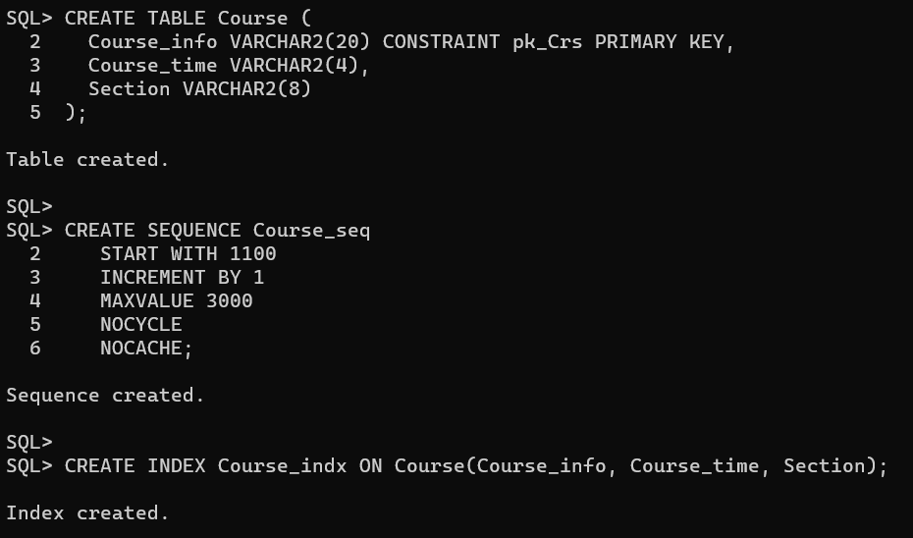

**Table Student**

CREATE TABLE Student (

S_info VARCHAR2(20) CONSTRAINT pk_std PRIMARY KEY,

Details VARCHAR2(25),

Name VARCHAR2(10),

Email VARCHAR2(20),

Username VARCHAR2(10),

Password VARCHAR2(20)

);

CREATE SEQUENCE Student_seq

START WITH 1000

INCREMENT BY 1

MAXVALUE 2000

NOCYCLE

NOCACHE;

CREATE INDEX Student_indx ON Student(S_info, Details, Name);

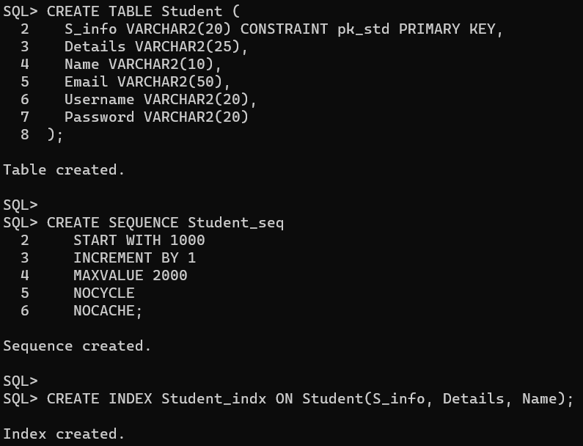

**Table Class**

CREATE TABLE Class (

Class_info VARCHAR2(20) CONSTRAINT pk_Cls PRIMARY KEY,

room_number NUMBER(4),

Sections VARCHAR2(8)

);

CREATE SEQUENCE Class_seq

START WITH 1000

INCREMENT BY 1

MAXVALUE 3000

NOCYCLE

NOCACHE;

CREATE INDEX Class_indx ON Class(Class_info, room_number, Sections)

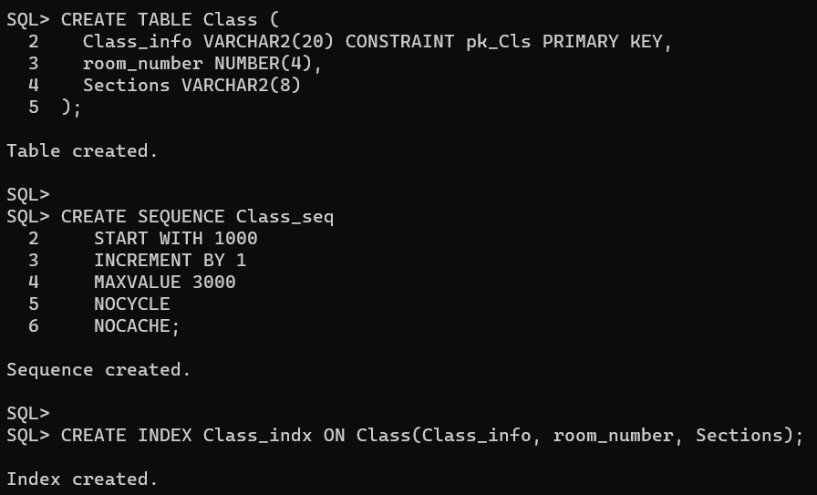

**Table Details Course**

CREATE TABLE DetailsCourse (

Course_d VARCHAR2(20) CONSTRAINT pk_crsdtls PRIMARY KEY,

Credit_per_course NUMBER(4),

Course_credit_fee NUMBER(8)

);

CREATE SEQUENCE CourseDetails_seq

START WITH 1300

INCREMENT BY 1

MAXVALUE 2000

NOCYCLE

NOCACHE;

CREATE INDEX CourseDetails_indx ON DetailsCourse(Course_d, Credit_per_course, Course_credit_fee);

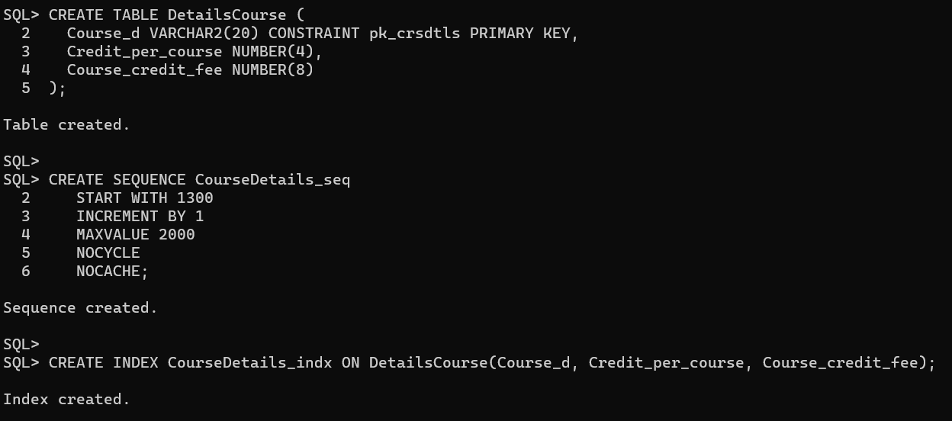

**Table Faculty**

CREATE TABLE Faculty (

Faculty_id NUMBER(8) CONSTRAINT pk_Flt PRIMARY KEY,

Courses VARCHAR2(30),

Time VARCHAR2(8),

Assigned_students NUMBER(30),

Name VARCHAR2(10),

Email VARCHAR2(20),

Password VARCHAR2(20)

);

CREATE SEQUENCE Faculty_seq

START WITH 1000

INCREMENT BY 1

MAXVALUE 3000

NOCYCLE

NOCACHE;

CREATE INDEX Faculty_indx ON Faculty(Faculty_id, Courses, Time, Assigned_students, Name);

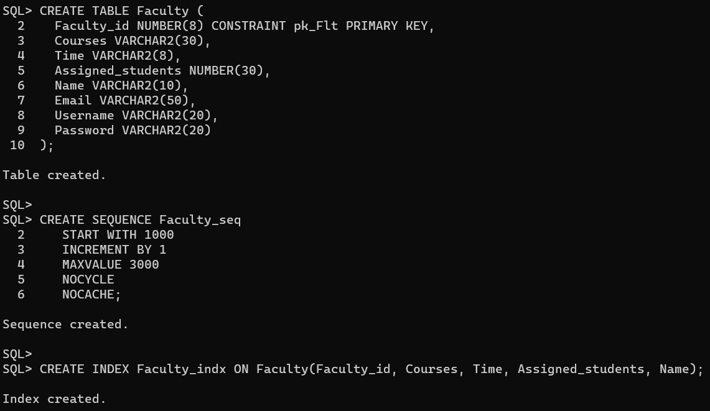

**Table Accountant**

CREATE TABLE Accountant (

Accountant_id NUMBER(5) CONSTRAINT pk_acc PRIMARY KEY,

Student_Information VARCHAR2(30),

S_transaction NUMBER(8),

Students_id NUMBER(7),

Course_info VARCHAR2(20)

);

ALTER TABLE Accountant ADD CONSTRAINT fk_acc_trns FOREIGN KEY (S_transaction) REFERENCES Transaction (S_transaction);

ALTER TABLE Accountant ADD CONSTRAINT fk_acc_std_id FOREIGN KEY (Students_id) REFERENCES Stdsid(Students_id);

ALTER TABLE Accountant ADD CONSTRAINT fk_acc_crs_info FOREIGN KEY (Course_info) REFERENCES Course (Course_info);

CREATE SEQUENCE Accountant_seq

START WITH 1200

INCREMENT BY 1

MAXVALUE 4000

NOCYCLE

NOCACHE;

CREATE INDEX Accountant_indx ON Accountant(Accountant_id, Student_Information, S_transaction, Students_id, Course_info);

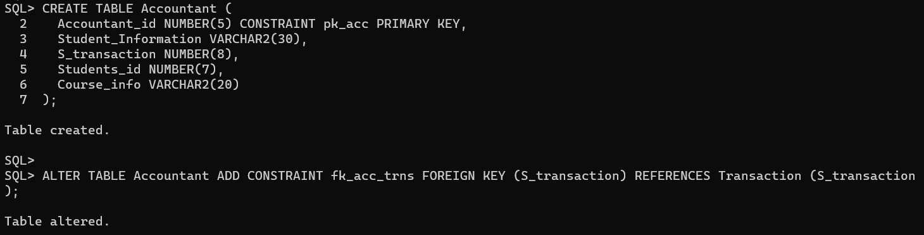

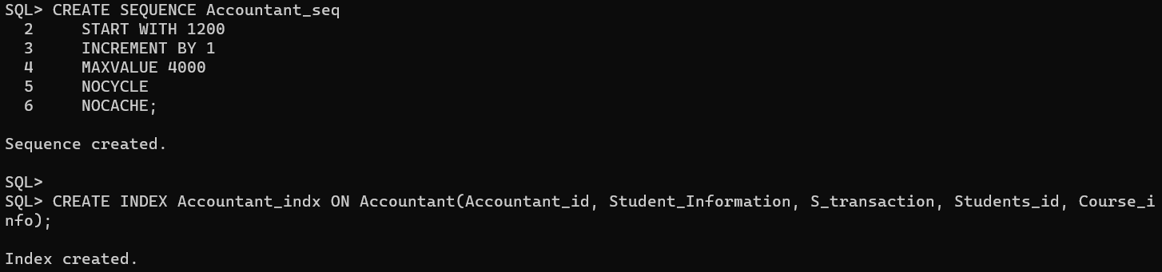

**Table Stdsid**

CREATE TABLE Stdsid (

Students_id NUMBER(7) CONSTRAINT pk_Stds_id PRIMARY KEY,

Assigned_Course VARCHAR2(20),

Credit_per_course VARCHAR2(4),

Total_creadit_fee NUMBER(8),

Course_info VARCHAR2(20),

Department_id NUMBER(5),

S_info VARCHAR2(30),

Course_id NUMBER(5),

class_info VARCHAR2(20)

);

ALTER TABLE Stdsid ADD CONSTRAINT fk_std_crs FOREIGN KEY (Course_info) REFERENCES Course (Course_info);

ALTER TABLE Stdsid ADD CONSTRAINT fk_std_dept FOREIGN KEY (Department_id) REFERENCES Dept (Department_id);

ALTER TABLE Stdsid ADD CONSTRAINT fk_std_S FOREIGN KEY (S_info) REFERENCES Student (S_info);

ALTER TABLE Stdsid ADD CONSTRAINT fk_std_crsid FOREIGN KEY (Course_id) REFERENCES Course_id (Course_id);

ALTER TABLE Stdsid ADD CONSTRAINT fk_std_cls FOREIGN KEY (class_info) REFERENCES Class (Class_info);

CREATE SEQUENCE Stdsid_seq

START WITH 1200

INCREMENT BY 1

MAXVALUE 4000

NOCYCLE

NOCACHE;

CREATE INDEX Stdsid_indx ON Stdsid(Students_id, Assigned_Course, Credit_per_course, Total_creadit_fee, Course_info, Department_id, S_info, Course_id, class_info);

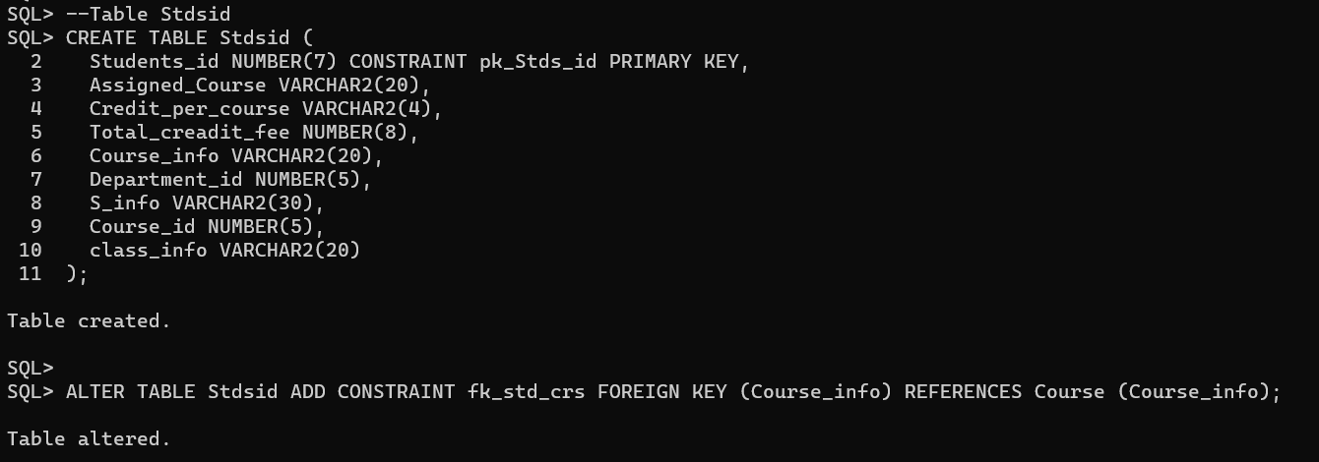

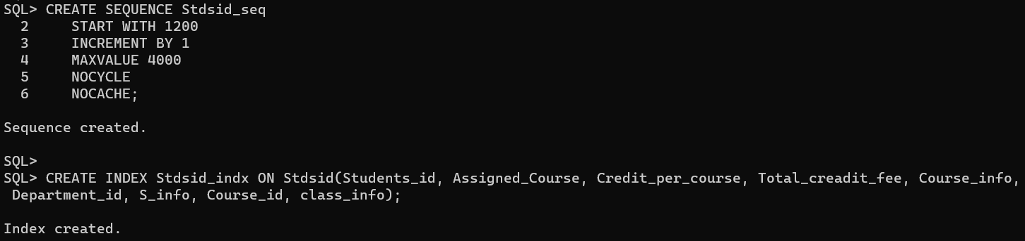

**Table Dept**

CREATE TABLE Dept (

Department_id NUMBER(5) CONSTRAINT pk_dept_id PRIMARY KEY,

Assigned_faculty VARCHAR2(10),

Assigned_course VARCHAR2(20),

S_info VARCHAR2(30),

Course_id NUMBER(5),

class_info VARCHAR2(20),

Faculty_id NUMBER(8),

Course_d VARCHAR2(20)

);

ALTER TABLE Dept ADD CONSTRAINT fk_dept_std FOREIGN KEY (S_info) REFERENCES Student (S_info);

ALTER TABLE Dept ADD CONSTRAINT fk_dept_crs FOREIGN KEY (Course_id) REFERENCES Course_id (Course_id);

ALTER TABLE Dept ADD CONSTRAINT fk_dept_cls FOREIGN KEY (class_info) REFERENCES Class (Class_info);

ALTER TABLE Dept ADD CONSTRAINT fk_dept_fclt FOREIGN KEY (Faculty_id) REFERENCES Faculty (Faculty_id);

ALTER TABLE Dept ADD CONSTRAINT fk_dept_crsd FOREIGN KEY (Course_d) REFERENCES DetailsCourse (Course_d);

CREATE SEQUENCE Dept_seq

START WITH 1200

INCREMENT BY 1

MAXVALUE 4000

NOCYCLE

NOCACHE;

CREATE INDEX Dept_indx ON Dept(Department_id, Assigned_faculty, Assigned_course, S_info, Course_id, class_info, Faculty_id, Course_d);

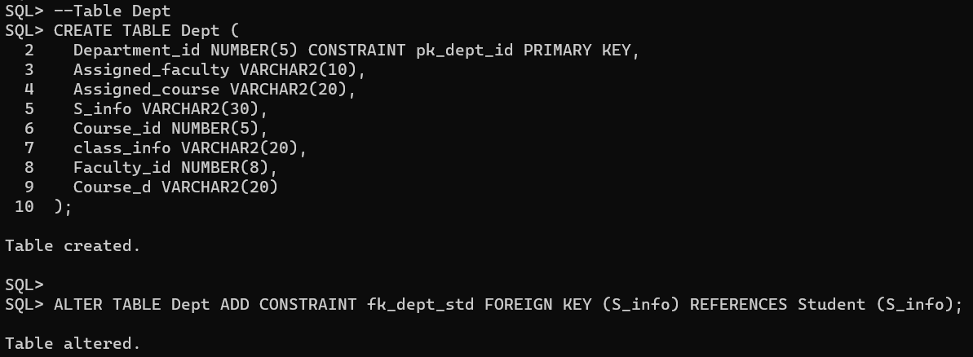

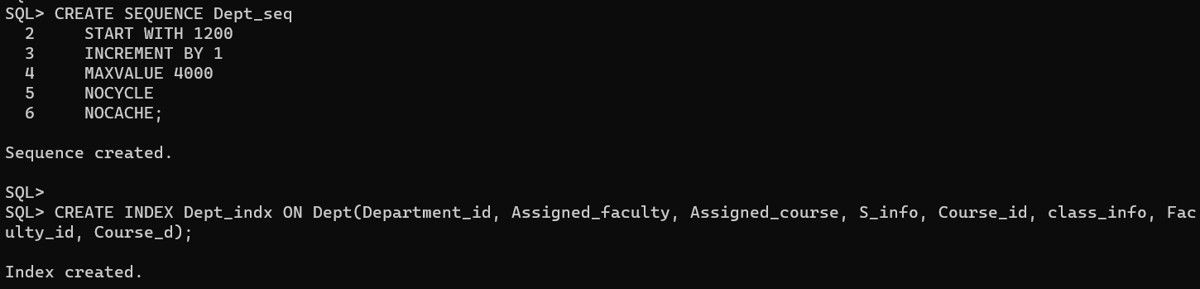

**Table Course Id**

CREATE TABLE Course_id (

Course_id NUMBER(5) CONSTRAINT pk_crsid PRIMARY KEY,

Time VARCHAR2(8),

Number_of_student VARCHAR2(20),

Assign_student_detail VARCHAR2(30),

Name VARCHAR2(20),

Class_info VARCHAR2(20),

Faculty_id NUMBER(8),

Course_d VARCHAR2(20)

);

ALTER TABLE Course_id ADD CONSTRAINT fk_crsii_info FOREIGN KEY (Class_info) REFERENCES Class (Class_info);

ALTER TABLE Course_id ADD CONSTRAINT fk_crsii_Faculty FOREIGN KEY (Faculty_id) REFERENCES Faculty (Faculty_id);

ALTER TABLE Course_id ADD CONSTRAINT fk_crsii_Course FOREIGN KEY (Course_d) REFERENCES DetailsCourse (Course_d);

CREATE SEQUENCE Courseid_seq

START WITH 1200

INCREMENT BY 1

MAXVALUE 4000

NOCYCLE

NOCACHE;

CREATE INDEX Courseid_indx ON Course_id(Course_id, Time, Assign_student_detail, Name, Class_info, Faculty_id, Course_d);

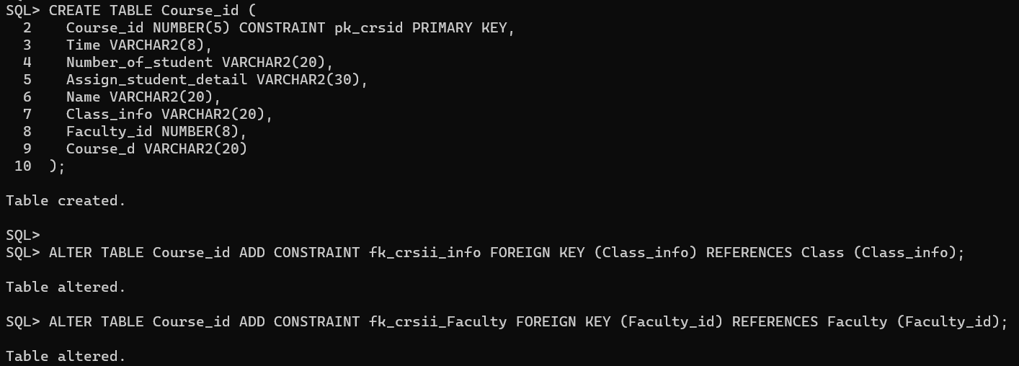

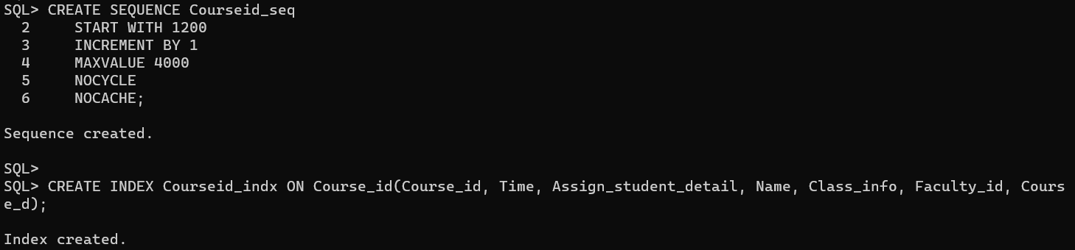

**Data Insertion:**

INSERT INTO Faculty (Faculty_id, Courses, Time, Assigned_students, Name, Username, Password, Email)

VALUES (1001, 'Computer Science', '13:00', 30, 'Jane', 'jane123', 'password123', 'jane@example.com');

INSERT INTO Faculty (Faculty_id, Courses, Time, Assigned_students, Name, Username, Password, Email)

VALUES (1002, 'Physics', '11:00', 20, 'Michael', 'michael567', 'pass4321', 'michael@example.com');

INSERT INTO Faculty (Faculty_id, Courses, Time, Assigned_students, Name, Username, Password, Email)

VALUES (1003, 'History', '09:00', 15, 'Sarah', 'sarah321', 'abc@123', 'sarah@example.com');

INSERT INTO Faculty (Faculty_id, Courses, Time, Assigned_students, Name, Username, Password, Email)

VALUES (1004, 'Mathematics', '10:00', 25, 'John', 'john_m', 'john456', 'john@example.com');

INSERT INTO Faculty (Faculty_id, Courses, Time, Assigned_students, Name, Username, Password, Email)

VALUES (1005, 'English', '14:00', 18, 'David', 'david_english', 'david789', 'david@example.com');

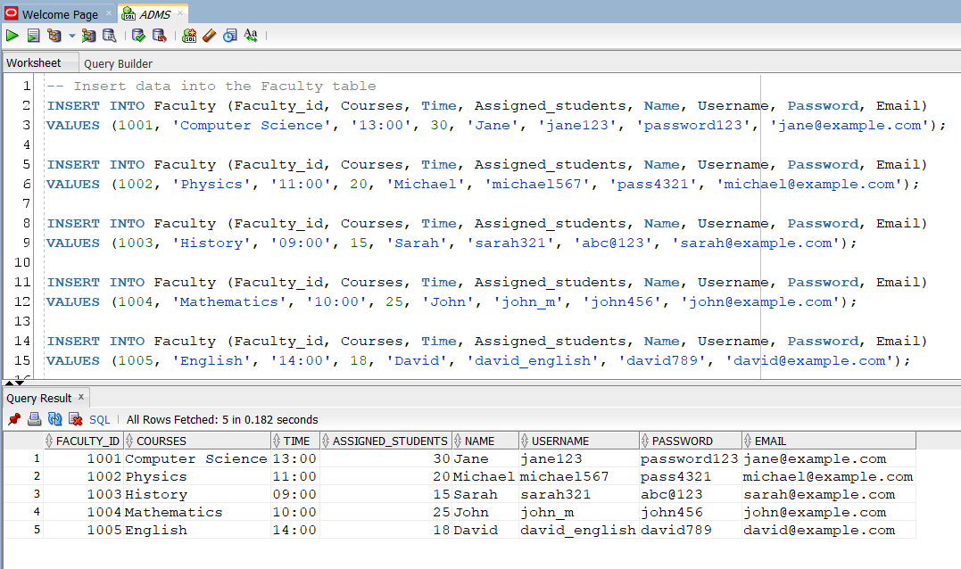

INSERT INTO Class (Class_info, room_number, Sections)

VALUES ('Class100', 106, 'C');

INSERT INTO Class (Class_info, room_number, Sections)

VALUES ('Class101', 106, 'C');

INSERT INTO Class (Class_info, room_number, Sections)

VALUES ('Class102', 105, 'A');

INSERT INTO Class (Class_info, room_number, Sections)

VALUES ('Class103', 106, 'B');

INSERT INTO Class (Class_info, room_number, Sections)

VALUES ('Class104', 106, 'B');

Select * from class;

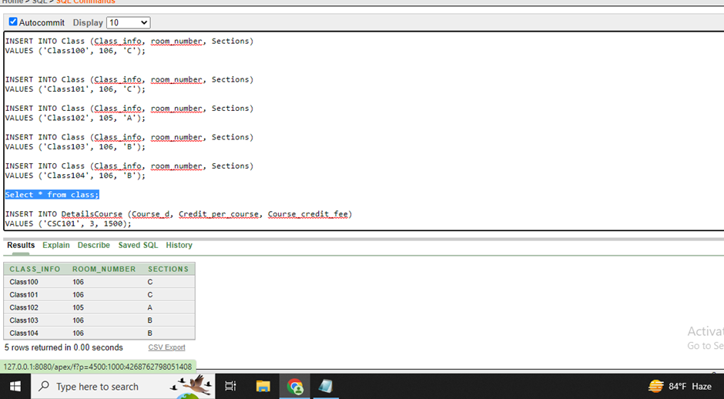

INSERT INTO DetailsCourse (Course_d, Credit_per_course, Course_credit_fee)

VALUES ('CSC101', 3, 1500);

INSERT INTO DetailsCourse (Course_d, Credit_per_course, Course_credit_fee)

VALUES ('CSC102', 3, 1500);

INSERT INTO DetailsCourse (Course_d, Credit_per_course, Course_credit_fee)

VALUES ('CSC103', 3, 1500);

INSERT INTO DetailsCourse (Course_d, Credit_per_course, Course_credit_fee)

VALUES ('CSC104', 3, 1500);

INSERT INTO DetailsCourse (Course_d, Credit_per_course, Course_credit_fee)

VALUES ('CSC105', 3, 1500);

select * from DetailsCourse;

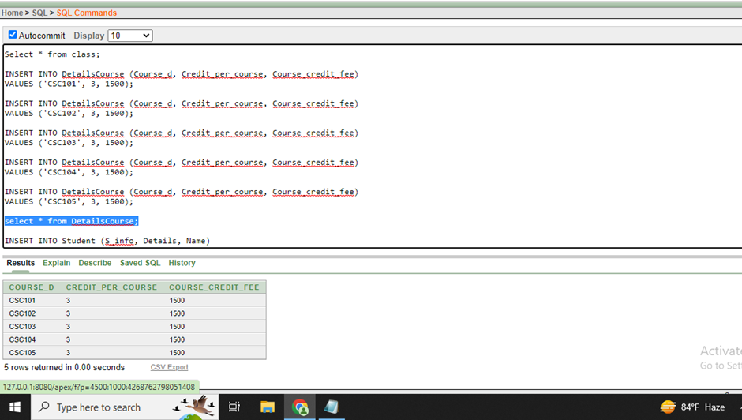

INSERT INTO Student (S_info, Details, Name, Username, Password, Email)

VALUES ('0001', 'CSE', 'Noboni', 'noboni123', 'pass1234', 'noboni@aiub.edu');

INSERT INTO Student (S_info, Details, Name, Username, Password, Email)

VALUES ('0002', 'CSE', 'Succho', 'succho123', 'succho4321', 'succho@aiub.edu');

INSERT INTO Student (S_info, Details, Name, Username, Password, Email)

VALUES ('0003', 'SE', 'Fahim', 'fahim99', 'abcxyz', 'fahim@aiub.edu');

INSERT INTO Student (S_info, Details, Name, Username, Password, Email)

VALUES ('0004', 'CSE', 'Sakib', 'sakib456', 'pass456', 'sakib@aiub.edu');

INSERT INTO Student (S_info, Details, Name, Username, Password, Email)

VALUES ('0005', 'SE', 'Ashesh', 'ashesh_m', 'ash123', 'ashesh@aiub.edu');

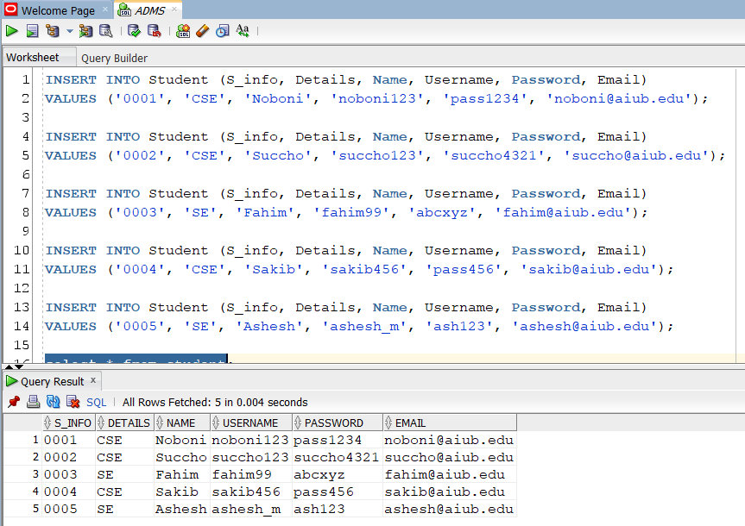

INSERT INTO Course (Course_info, Course_time, Section)

VALUES ('CSC101', '10.30-12.30', 'A');

INSERT INTO Course (Course_info, Course_time, Section)

VALUES ('CSC102', '8.30-11.00', 'F');

INSERT INTO Course (Course_info, Course_time, Section)

VALUES ('CSC103', '10.30-12.00', 'B');

INSERT INTO Course (Course_info, Course_time, Section)

VALUES ('CSC104', '2.30-5.00', 'A');

INSERT INTO Course (Course_info, Course_time, Section)

VALUES ('CSC105', '11.30-2.00', 'C');

select * from Course;

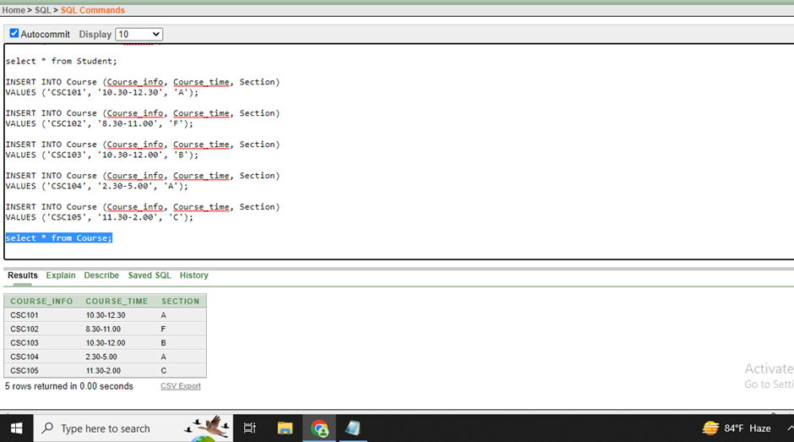

INSERT INTO Transaction (S_transaction, Student_pay, Student_due)

VALUES (Transaction_seq.NEXTVAL, 1000, 500);

INSERT INTO Transaction (S_transaction, Student_pay, Student_due)

VALUES (Transaction_seq.NEXTVAL, 2000, 1500);

INSERT INTO Transaction (S_transaction, Student_pay, Student_due)

VALUES (Transaction_seq.NEXTVAL, 1000, 500);

INSERT INTO Transaction (S_transaction, Student_pay, Student_due)

VALUES (Transaction_seq.NEXTVAL, 1030, 700);

INSERT INTO Transaction (S_transaction, Student_pay, Student_due)

VALUES (Transaction_seq.NEXTVAL, 1200, 500);

Select * from Transaction;

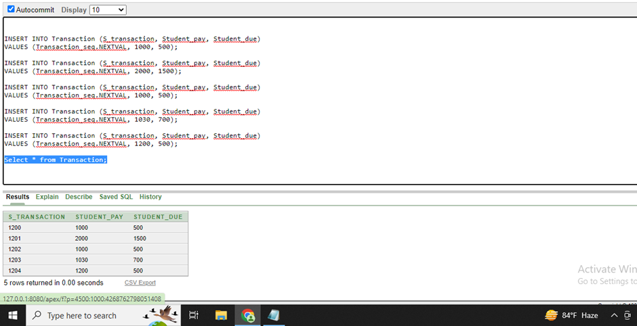

INSERT INTO Course_id (Course_id, Time, Number_of_student, Assign_student_detail, Name, Class_info, Faculty_id, Course_d)

VALUES(Courseid_seq.NEXTVAL, '10:00 AM', '20', 'Assigned students', 'Database Systems', 'Class101', 1001, 'CSC101');

INSERT INTO Course_id (Course_id, Time, Number_of_student, Assign_student_detail, Name, Class_info, Faculty_id, Course_d)

VALUES(Courseid_seq.NEXTVAL, '11:30 AM', '30', 'Assigned students', 'Database Systems', 'Class100', 1002, 'CSC102');

INSERT INTO Course_id (Course_id, Time, Number_of_student, Assign_student_detail, Name, Class_info, Faculty_id, Course_d)

VALUES(Courseid_seq.NEXTVAL, '8:30 AM', '24', 'Assigned students', 'Database Systems', 'Class102', 1003, 'CSC103');

INSERT INTO Course_id (Course_id, Time, Number_of_student, Assign_student_detail, Name, Class_info, Faculty_id, Course_d)

VALUES(Courseid_seq.NEXTVAL, '9:40 AM', '28', 'Assigned students', 'Database Systems', 'Class103', 1004, 'CSC104');

INSERT INTO Course_id (Course_id, Time, Number_of_student, Assign_student_detail, Name, Class_info, Faculty_id, Course_d)

VALUES(Courseid_seq.NEXTVAL, '2:30 AM', '32', 'Assigned students', 'Database Systems', 'Class104', 1005, 'CSC105');

select * from Course_id;

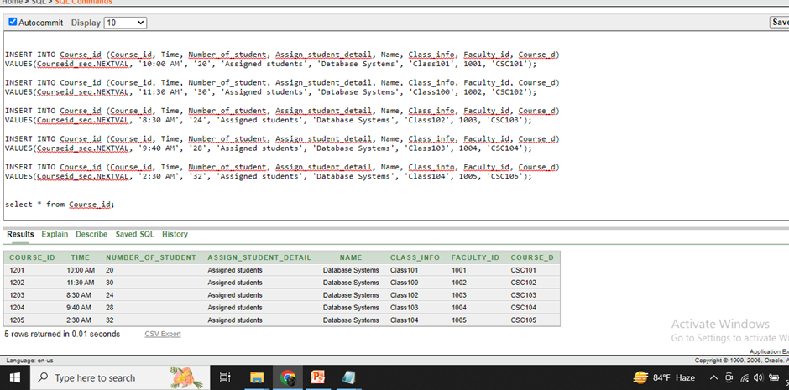

INSERT INTO Dept (Department_id, Assigned_faculty, Assigned_course, S_info, Course_id, class_info, Faculty_id, Course_d)

VALUES (101, 'FST', 'Biology', '0005', 1203, 'Class103', 1002, 'CSC101');

INSERT INTO Dept (Department_id, Assigned_faculty, Assigned_course, S_info, Course_id, class_info, Faculty_id, Course_d)

VALUES (102, 'BBA', 'Communications', '0003', 1202, 'Class104', 1003, 'CSC103');

INSERT INTO Dept (Department_id, Assigned_faculty, Assigned_course, S_info, Course_id, class_info, Faculty_id, Course_d)

VALUES (103, 'FST', 'Microprocessor', '0001', 1201, 'Class100', 1001, 'CSC102');

INSERT INTO Dept (Department_id, Assigned_faculty, Assigned_course, S_info, Course_id, class_info, Faculty_id, Course_d)

VALUES (104, 'ENG', 'English', '0004', 1204, 'Class103', 1003, 'CSC104');

INSERT INTO Dept (Department_id, Assigned_faculty, Assigned_course, S_info, Course_id, class_info, Faculty_id, Course_d)

VALUES (105, 'ART', 'Theme', '0002', 1205, 'Class101', 1005, 'CSC105');

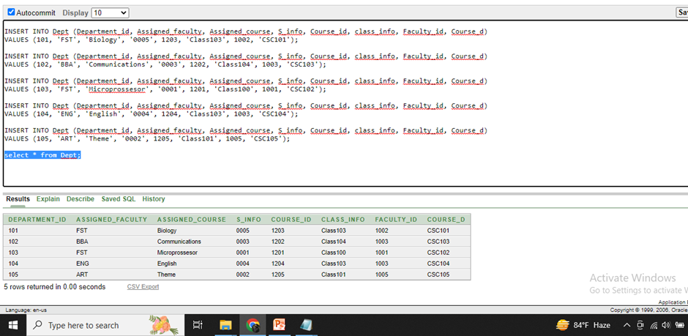

INSERT INTO Stdsid (Students_id, Assigned_Course, Credit_per_course, Total_creadit_fee, Course_info, Department_id, S_info, Course_id, Class_info)

VALUES (Stdsid_seq.NEXTVAL, 'Computer Science', '3', 15, 'CSC103', 104, '0002', 1204, 'Class103');

INSERT INTO Stdsid (Students_id, Assigned_Course, Credit_per_course, Total_creadit_fee, Course_info, Department_id, S_info, Course_id, Class_info)

VALUES (Stdsid_seq.NEXTVAL, 'OOP2', '3', 18, 'CSC102', 103, '0003', 1201, 'Class100');

INSERT INTO Stdsid (Students_id, Assigned_Course, Credit_per_course, Total_creadit_fee, Course_info, Department_id, S_info, Course_id, Class_info)

VALUES (Stdsid_seq.NEXTVAL, 'Compailor', '3', 12, 'CSC105', 102, '0001', 1202, 'Class104');

INSERT INTO Stdsid (Students_id, Assigned_Course, Credit_per_course, Total_creadit_fee, Course_info, Department_id, S_info, Course_id, Class_info)

VALUES (Stdsid_seq.NEXTVAL, 'Database', '3', 09, 'CSC101', 105, '0005', 1203, 'Class101');

INSERT INTO Stdsid (Students_id, Assigned_Course, Credit_per_course, Total_creadit_fee, Course_info, Department_id, S_info, Course_id, Class_info)

VALUES (Stdsid_seq.NEXTVAL, 'Computer network', '3', 12, 'CSC104', 101, '0004', 1205, 'Class102');

select * from stdsid;

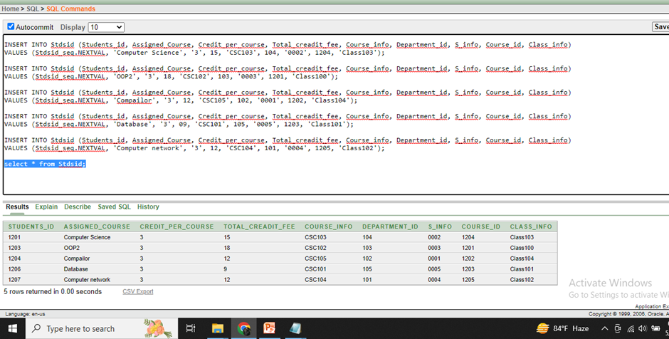

INSERT INTO Accountant (Accountant_id, Student_Information,S_transaction, Students_id, Course_info)

VALUES (4450, 'payment', '1200', '1204', 'CSC104');

INSERT INTO Accountant (Accountant_id, Student_Information, S_transaction, Students_id, Course_info)

VALUES (4451, 'payment', '1202', '1207', 'CSC102');

INSERT INTO Accountant (Accountant_id, Student_Information,S_transaction, Students_id, Course_info)

VALUES (4452, 'payment', '1200', '1206', 'CSC101');

INSERT INTO Accountant (Accountant_id, Student_Information,S_transaction, Students_id, Course_info)

VALUES (4453, 'payment', '1203', '1203', 'CSC103');

INSERT INTO Accountant (Accountant_id, Student_Information,S_transaction, Students_id, Course_info)

VALUES (4454, 'payment', '1202', '1201', 'CSC105');

select * from Accountant;

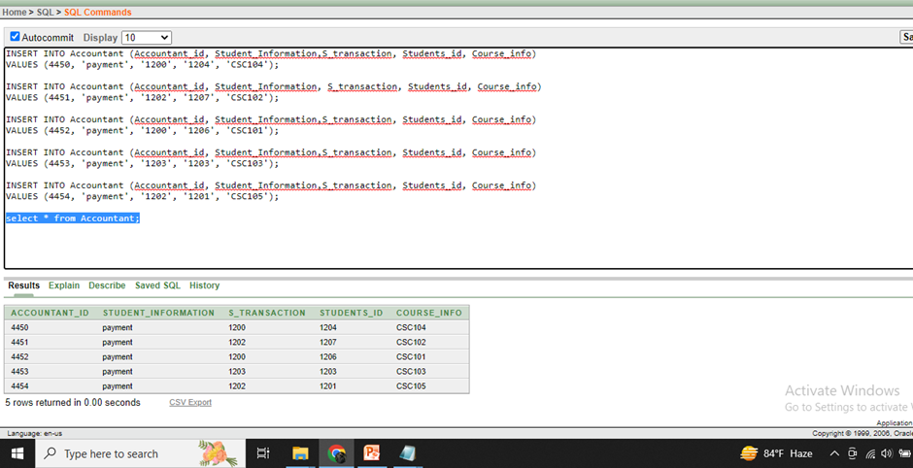

**Query Writing:**

**SQL**

**Single-row function**

1. Find the room number and section.

Ans:

Select concat (room_number, sections)

From Class;

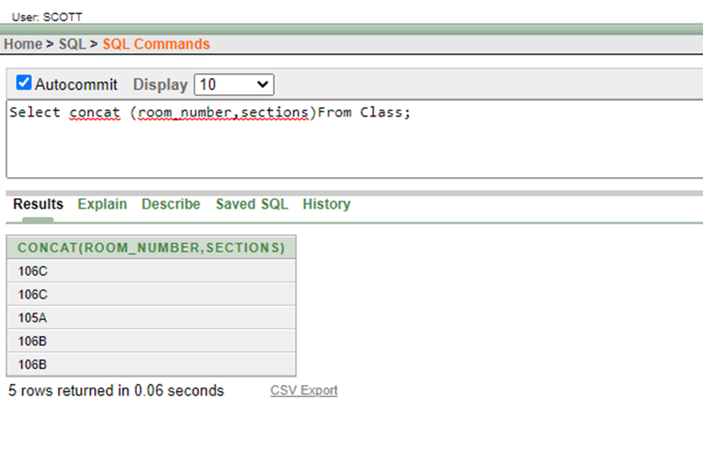

1. What will be the length of the name?

Ans:

Select name length(name)

From DetailsCourse;

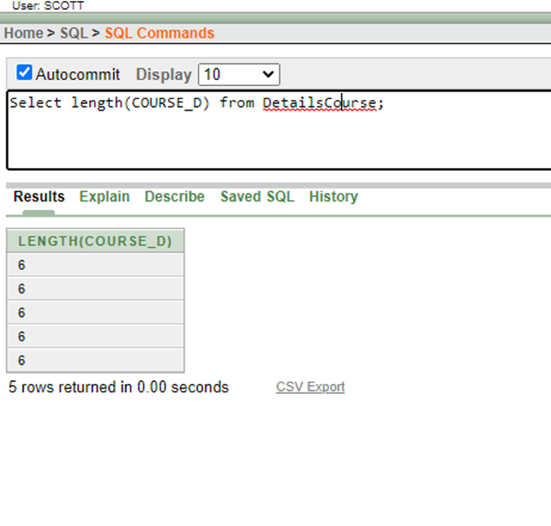

1. Print the assigned courses.

Ans:

Select Assigned_course,instr (Assigned_course, ‘C’)

From stdsid;

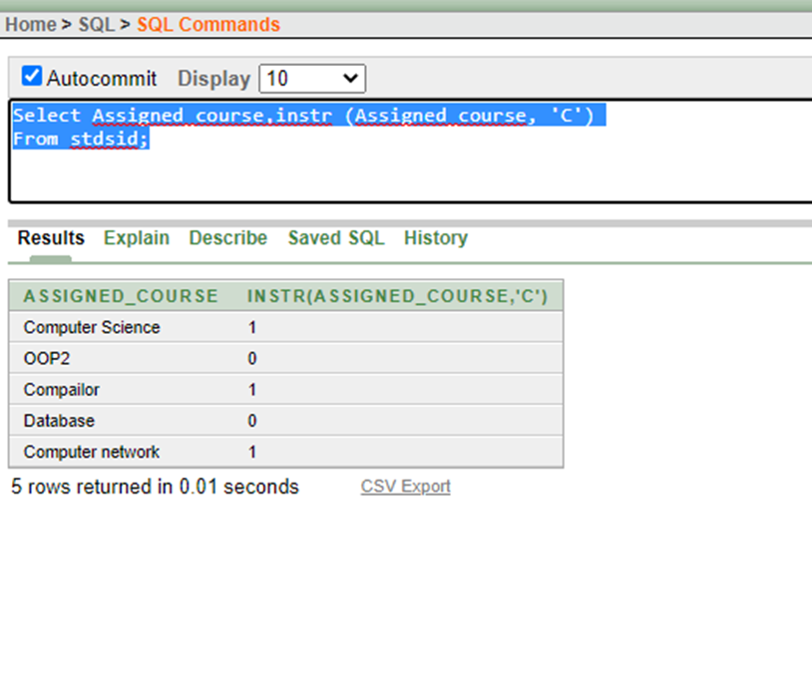

**Group function**

1. Find the max due amount of students.

Ans:

select max(Student_due)

from Transaction;

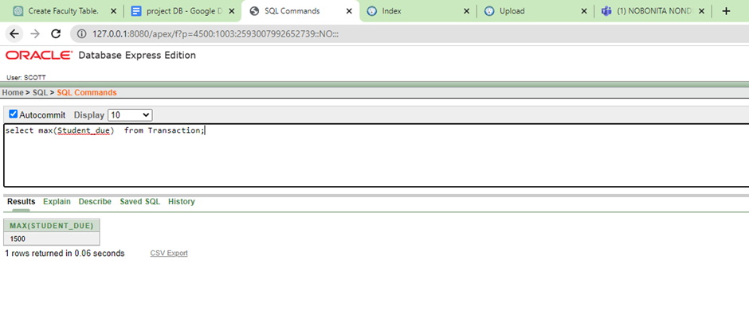

1. Print the minimum student pay.

Ans:

select min(Student_pay)

from Transaction;

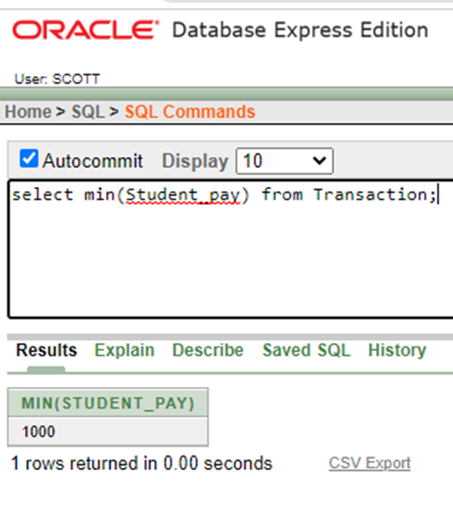

1. How many students have been assigned by faculty?

Ans:

select max(Assigned_students)

from Faculty

group by Faculty_id;

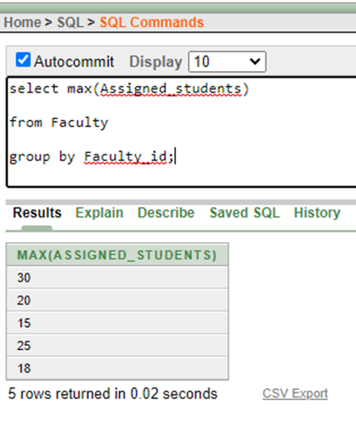

**Subquery**

1. Print the names of students whose details match those of students whose names start with 'Su'.

Ans:

Select the name

From Student

Where details= (select details

From Student

Where Name Like ’Su%’);

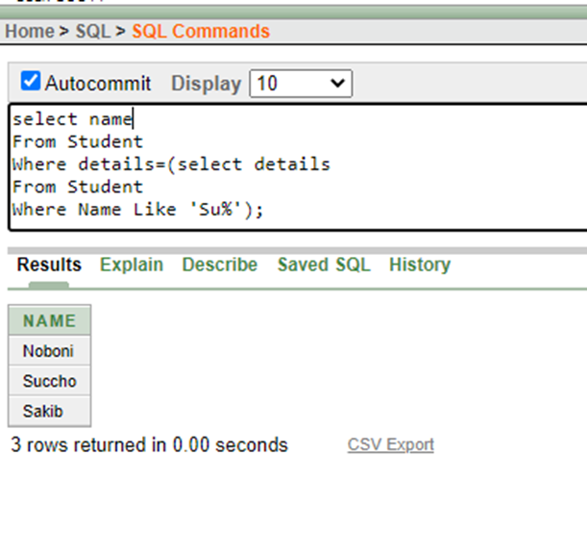

1. Print the names and times of faculty members who have the same time as those teaching the 'COMPUTER SCIENCE' course.

Ans:

Select name,time

From Faculty

Where time= (select time

From faculty

Where Course_name=’COMPUTER SCIENCE’);

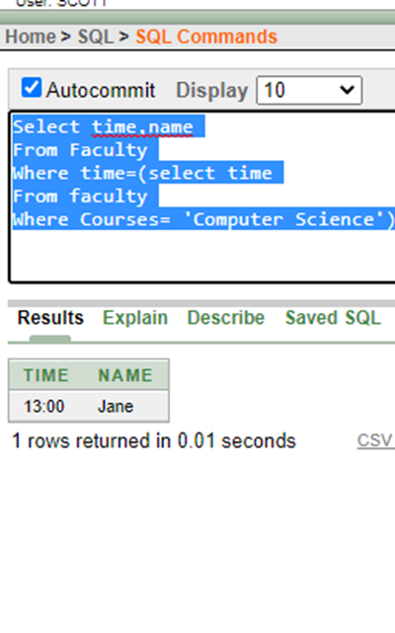

1. Print the names and number of assigned students for faculty members who have the minimum number of assigned students among all the faculty members.

Ans:

Select name,assigned_students

From faculty

Where assigned_students=(select min(assigned_students)

From Faculty)

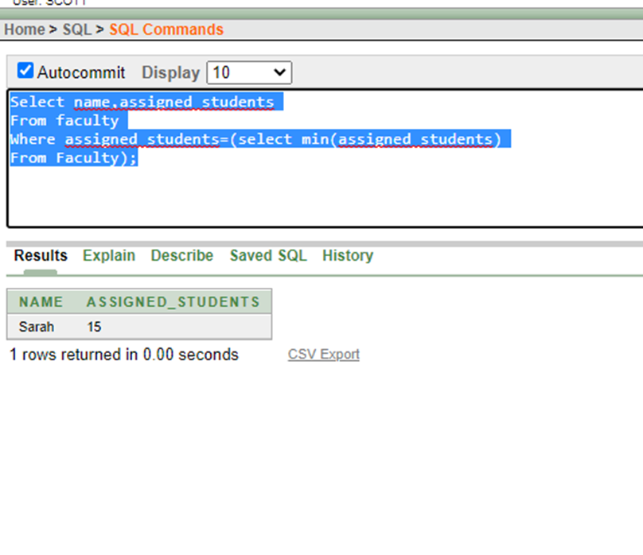

**Joining**

1. Find student details and department.

Ans:

SELECT Name,Details,Department_ID

FROM Stdsid t

JOIN Student s

ON t.S_INFO = s.S_INFO;

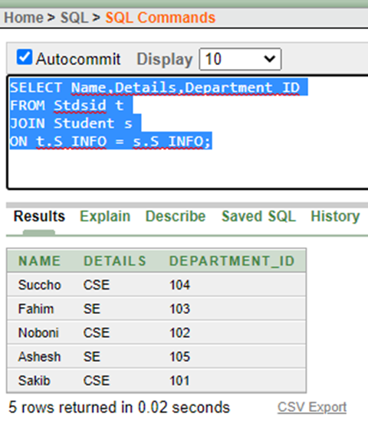

1. Get the course room number and faculty.

Ans:

SELECT Course_id.Course_d, Course_id.Class_info, Dept.Assigned_faculty

FROM Course_id

JOIN Dept

ON Course_id.Course_d = Dept.Course_d;

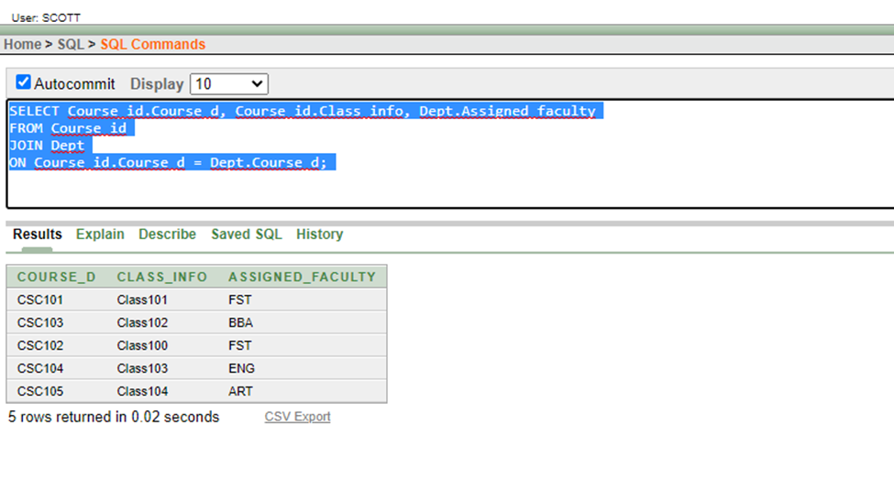

1. Find all information for all courses.

Ans:

SELECT *

FROM dept d

JOIN Stdsid s

ON d.COURSE_D = s.COURSE_INFO

JOIN course_id c

ON c.course_id = s.course_id

JOIN Student st

ON st.S_INFO = s.S_INFO;

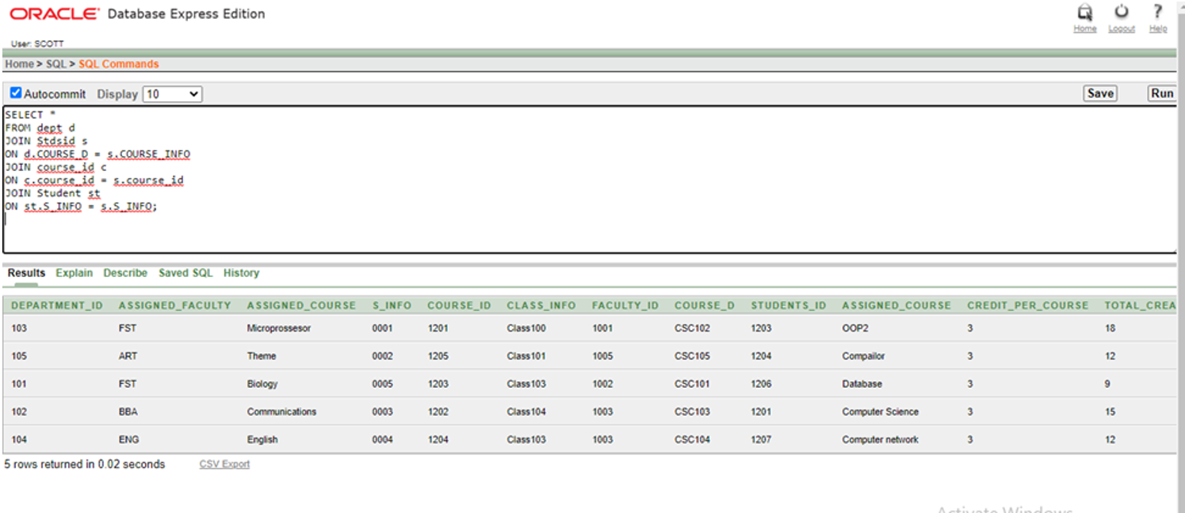

**View**

1. Create a view to get student names.

Ans:

CREATE VIEW student_names AS

SELECT NAME FROM Student;

SELECT * FROM student_names;

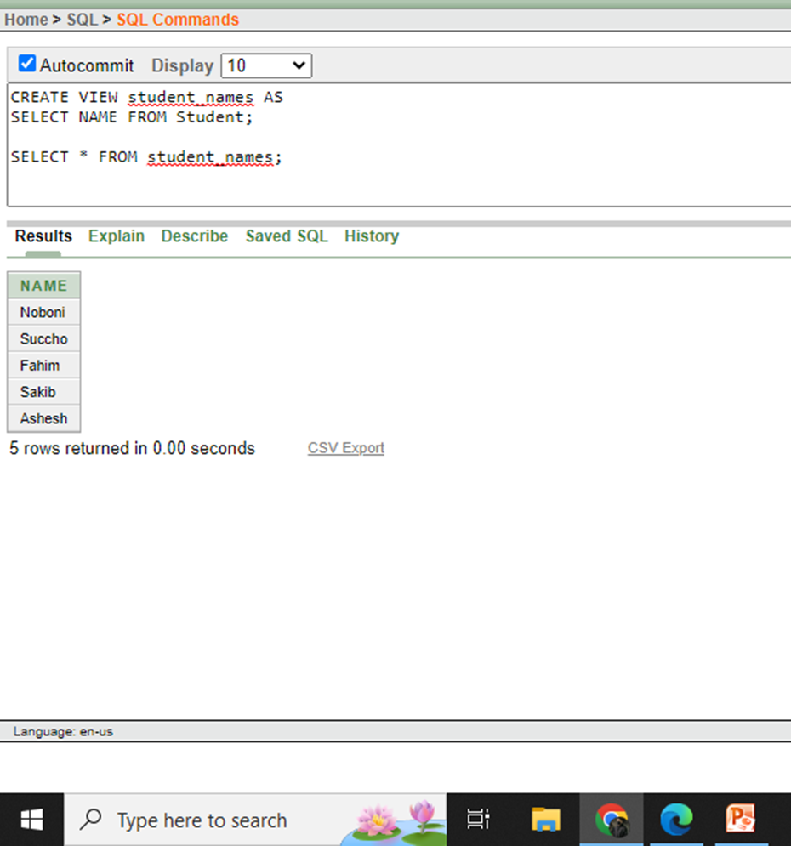

1. Create a view to get Faculty names.

Ans:

CREATE VIEW faculty_names_view AS

SELECT Name FROM Faculty;

SELECT * FROM faculty_names_view;

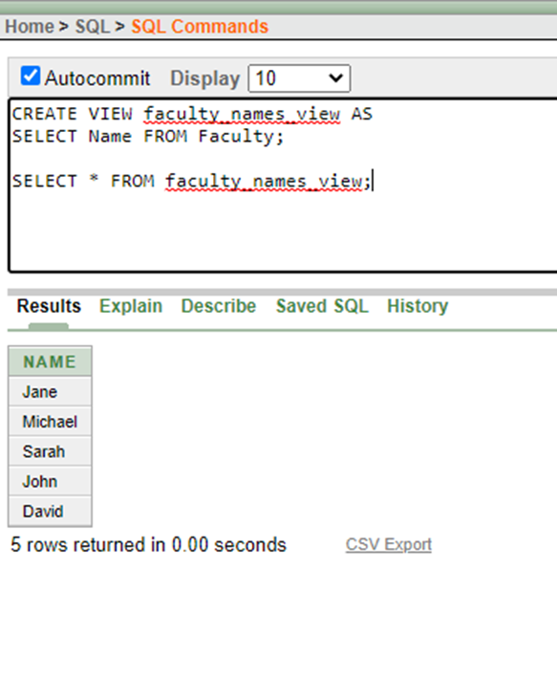

1. Create a view to calculate the total sections in a course.

Ans:

CREATE VIEW total_sections AS

SELECT Course_info, COUNT(*) as num_sections

FROM Course

GROUP BY Course_info;

select * from course;

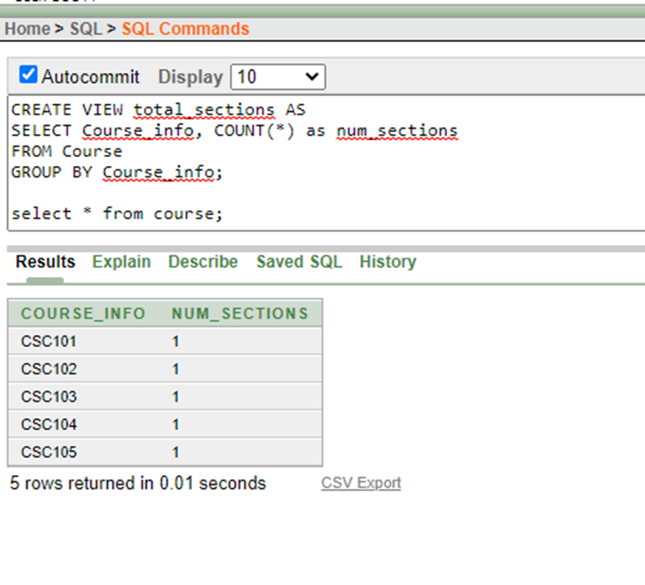

**Synonym**

1. Create a synonym for DetailsCourse.

Ans:

CREATE SYNONYM Details

FOR DetailsCourse;

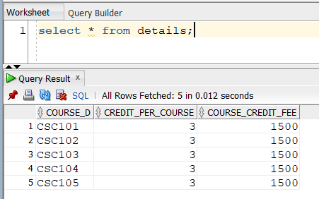

1. Create a synonym for Stdsid.

Ans:

CREATE SYNONYM Stdsid_syn

FOR Stdsid;

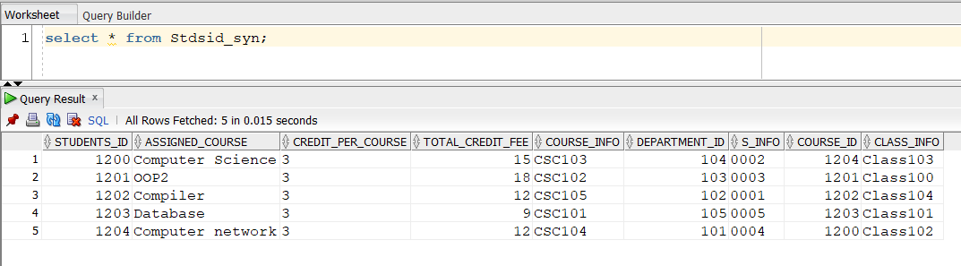

1. Create a synonym for Dept.

Ans:

CREATE SYNONYM Syn_Dept

FOR Dept;

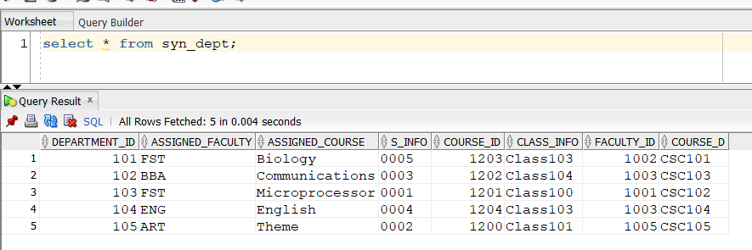

**PL/SQL**

**Function**

1. Write a function to calculate the total credit fee.

Ans:

CREATE OR REPLACE FUNCTION calculate_credit_fee(p_credit_per_course IN NUMBER, p_num_courses IN NUMBER)

RETURN NUMBER IS

v_total_fee NUMBER;

BEGIN

v_total_fee := p_credit_per_course * p_num_courses * 5500; -- AIUB per credit fee is 5500

RETURN v_total_fee;

END;

/

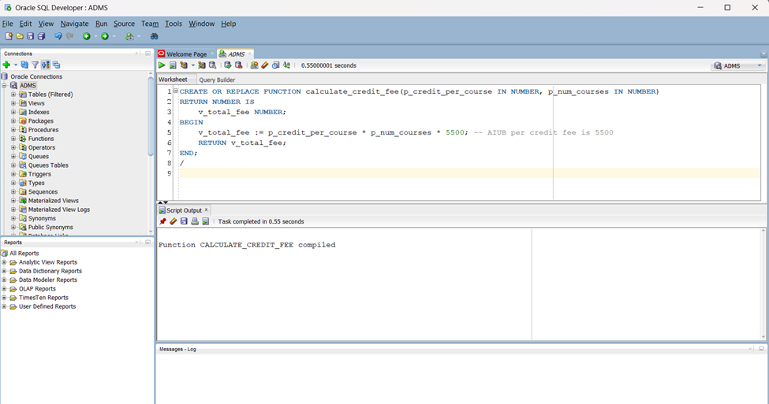

1. Write a function to get student email.

Ans:

CREATE OR REPLACE FUNCTION get_student_email(p_student_id IN NUMBER)

RETURN VARCHAR2 IS

v_email VARCHAR2(50);

BEGIN

SELECT Email INTO v_email FROM Student WHERE S_INFO = p_student_id;

RETURN v_email;

EXCEPTION

WHEN NO_DATA_FOUND THEN

RETURN NULL;

END;

/

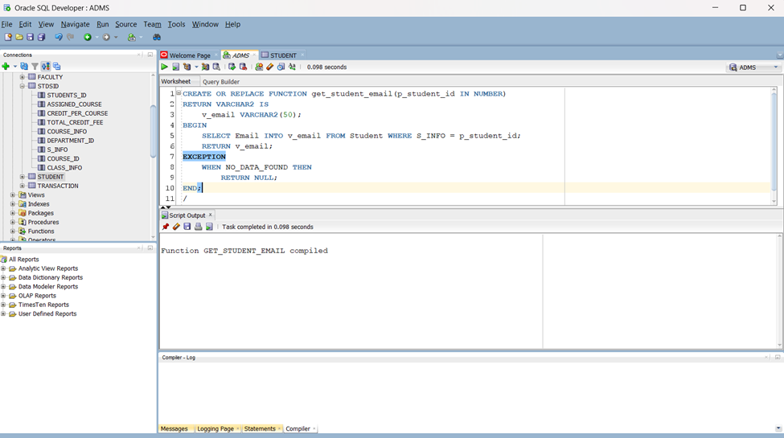

1. Write a function to check course availability.

Ans:

CREATE OR REPLACE FUNCTION check_course_availability(p_course_info IN VARCHAR2)

RETURN BOOLEAN IS

v_count NUMBER;

BEGIN

SELECT COUNT(*) INTO v_count FROM Course WHERE Course_info = p_course_info;

RETURN v_count > 0;

END;

/

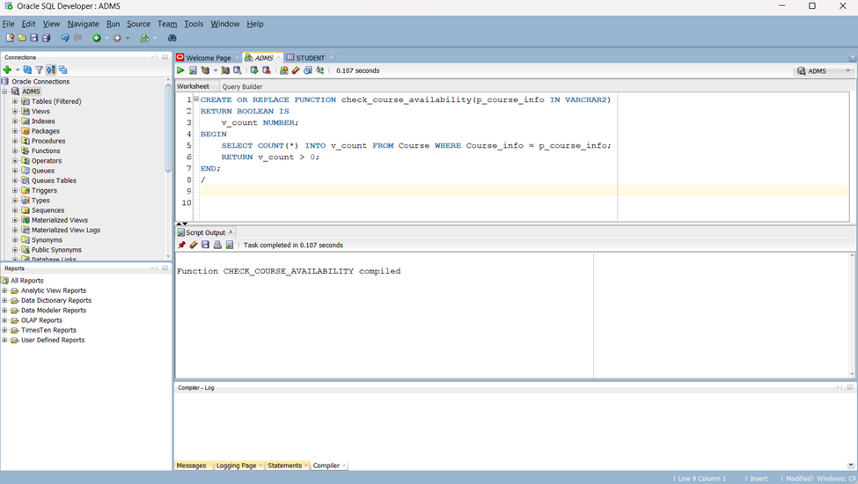

**Procedure**

1. Write a procedure for updating the course.

Ans:

create or replace PROCEDURE update_course(

p_course_info IN VARCHAR2,

p_new_course_time IN VARCHAR2,

p_new_section IN VARCHAR2

)

IS

BEGIN

UPDATE Course

SET Course_time = p_new_course_time,

Section = p_new_section

WHERE Course_info = p_course_info;

COMMIT;

EXCEPTION

WHEN NO_DATA_FOUND THEN

DBMS_OUTPUT.PUT_LINE('Course not found.');

WHEN OTHERS THEN

DBMS_OUTPUT.PUT_LINE('An error occurred: ' || SQLERRM);

ROLLBACK;

END;

/

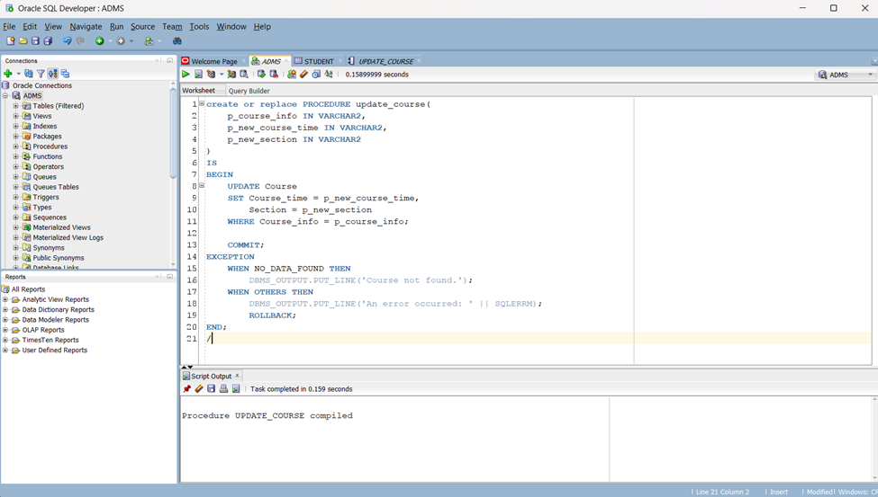

1. Write a procedure to update the student’s password.

Ans:

CREATE OR REPLACE PROCEDURE update_student_password(

p_s_info IN VARCHAR2,

p_new_password IN VARCHAR2

)

IS

BEGIN

UPDATE Student SET Password = p_new_password WHERE S_info = p_s_info;

COMMIT;

DBMS_OUTPUT.PUT_LINE('Password updated successfully.');

EXCEPTION

WHEN NO_DATA_FOUND THEN

DBMS_OUTPUT.PUT_LINE('Student not found.');

WHEN OTHERS THEN

DBMS_OUTPUT.PUT_LINE('An error occurred: ' || SQLERRM);

END;

/



1. Write a procedure to assign faculty to the course.

Ans:

CREATE OR REPLACE PROCEDURE assign_faculty_to_course(p_faculty_id IN NUMBER, p_course_info IN VARCHAR2)

IS

BEGIN

UPDATE Faculty SET Courses = p_course_info WHERE Faculty_id = p_faculty_id;

COMMIT;

EXCEPTION

WHEN OTHERS THEN

ROLLBACK;

RAISE;

END;

/

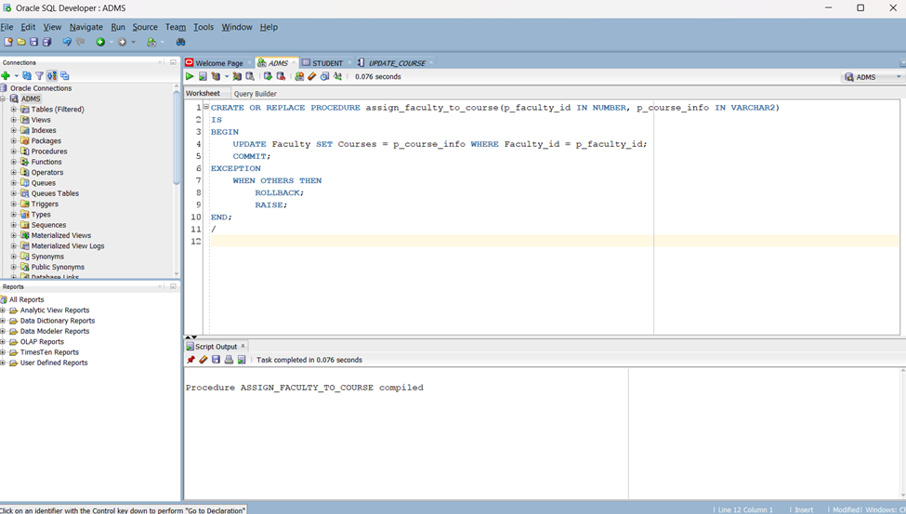

**Record**

1. Write a record to store faculty information.

Ans:

DECLARE

TYPE FacultyRecord IS RECORD (

faculty_id Faculty.Faculty_id%TYPE,

faculty_name Faculty.Name%TYPE,

faculty_courses Faculty.Courses%TYPE

);

v_faculty FacultyRecord;

BEGIN

SELECT Faculty_id, Name, Courses INTO v_faculty FROM Faculty WHERE Faculty_id = 1003;

DBMS_OUTPUT.PUT_LINE('Faculty ID: ' || v_faculty.faculty_id || ', Name: ' || v_faculty.faculty_name || ', Courses: ' || v_faculty.faculty_courses);

END;

/



1. Write a record to store course information.

Ans:

DECLARE

TYPE CourseRecord IS RECORD (

course_code Course.Course_info%TYPE,

course_time Course.Course_time%TYPE,

course_section Course.Section%TYPE

);

v_course CourseRecord;

BEGIN

SELECT Course_info, Course_time, Section INTO v_course FROM Course WHERE Course_info = 'CSC101';

DBMS_OUTPUT.PUT_LINE('Course Code: ' || v_course.course_code || ', Time: ' || v_course.course_time || ', Section: ' || v_course.course_section);

END;

/

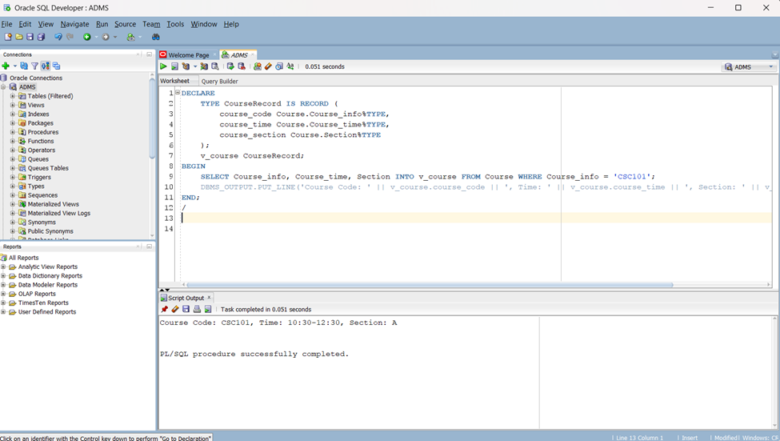

1. Write a record to store student information.

Ans:

DECLARE

TYPE StudentRecord IS RECORD (

student_id Student.s_info%TYPE,

student_name Student.Name%TYPE,

student_email Student.Email%TYPE

);

v_student StudentRecord;

BEGIN

SELECT s_info, Name, Email INTO v_student FROM Student WHERE s_info = 0001;

DBMS_OUTPUT.PUT_LINE('Student ID: ' || v_student.student_id || ', Name: ' || v_student.student_name || ', Email: ' || v_student.student_email);

END;

/



**Cursor**

1. Write a cursor to list students in a course.

Ans:

DECLARE

CURSOR student_cursor IS

SELECT S_info, Name FROM Student WHERE S_info IN (SELECT S_info FROM Stdsid WHERE Course_info = 'CSC101');

v_student_id Student.S_info%TYPE;

v_student_name Student.Name%TYPE;

BEGIN

OPEN student_cursor;

LOOP

FETCH student_cursor INTO v_student_id, v_student_name;

EXIT WHEN student_cursor%NOTFOUND;

DBMS_OUTPUT.PUT_LINE('Student ID: ' || v_student_id || ', Name: ' || v_student_name);

END LOOP;

CLOSE student_cursor;

END;

/



1. Write a cursor to calculate total credit fees.

Ans:

DECLARE

CURSOR course_cursor IS

SELECT Course_D, Credit_per_course FROM DetailsCourse;

v_course_info DetailsCourse.Course_d%TYPE;

v_credit_per_course detailscourse.course_credit_fee%TYPE;

v_total_fee NUMBER := 0;

BEGIN

OPEN course_cursor;

LOOP

FETCH course_cursor INTO v_course_info, v_credit_per_course;

EXIT WHEN course_cursor%NOTFOUND;

v_total_fee := v_total_fee + (v_credit_per_course * 5500); -- AIUB per credit 5500

END LOOP;

CLOSE course_cursor;

DBMS_OUTPUT.PUT_LINE('Total Credit Fees: ' || v_total_fee);

END;

/



1. Write a cursor to update students’ email domains.

Ans:

DECLARE

CURSOR student_cursor IS

SELECT s_info, Email FROM Student WHERE Email LIKE '%@example.com';

v_student_id student.s_info%TYPE;

v_student_email Student.Email%TYPE;

BEGIN

OPEN student_cursor;

LOOP

FETCH student_cursor INTO v_student_id, v_student_email;

EXIT WHEN student_cursor%NOTFOUND;

UPDATE Student SET Email = REPLACE(v_student_email, '@example.com', '@aiub.edu') WHERE s_info = v_student_id;

COMMIT;

END LOOP;

CLOSE student_cursor;

END;

/



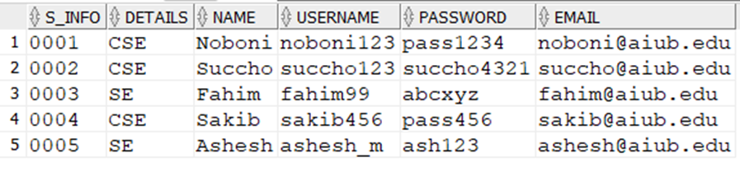

**Trigger**

1. Write a trigger to update the course credit fee.

Ans:

CREATE OR REPLACE TRIGGER update_credit_fee

BEFORE INSERT ON DetailsCourse

FOR EACH ROW

BEGIN

:NEW.Course_credit_fee := :NEW.Credit_per_course * 5500; -- AIUB per credit fee 5500

END;

/

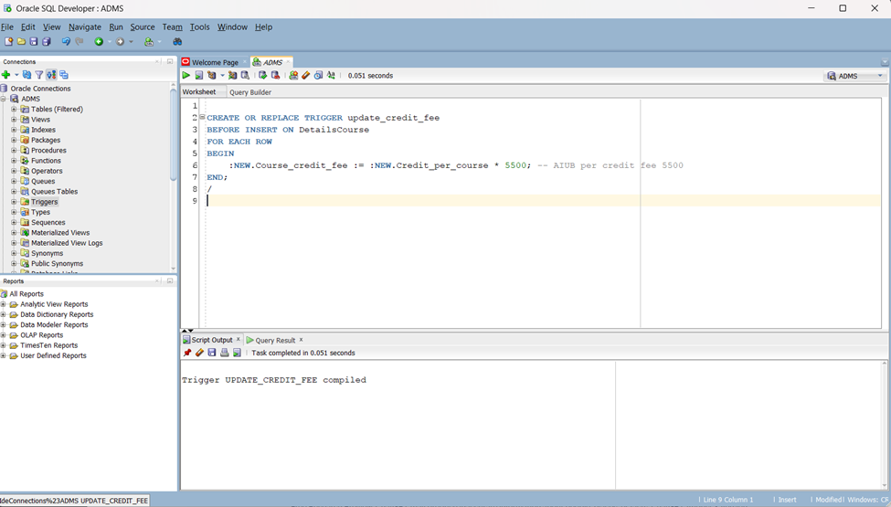

1. Write a trigger to enforce the maximum number of students in a class.

Ans:

CREATE OR REPLACE TRIGGER enforce_max_students

BEFORE INSERT ON Stdsid

FOR EACH ROW

DECLARE

v_max_students NUMBER := 30;

v_current_students NUMBER;

BEGIN

SELECT COUNT(*) INTO v_current_students FROM Stdsid WHERE Class_info = :NEW.Class_info;

IF v_current_students >= v_max_students THEN

RAISE_APPLICATION_ERROR(-20001, 'Class is full. Cannot enroll more students.');

END IF;

END;

/

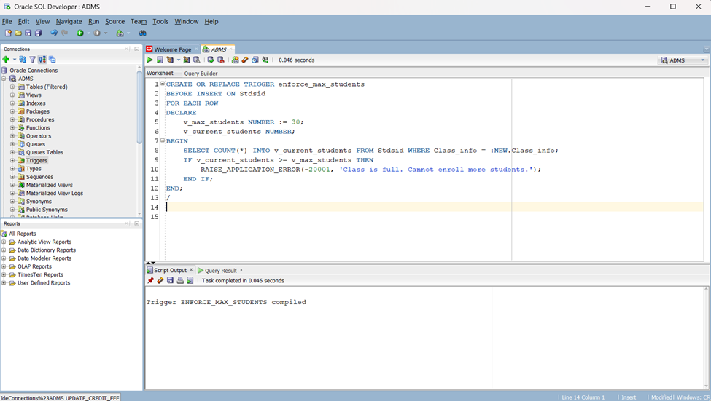

1. Write a trigger to change the faculty email domain.

Ans:

CREATE OR REPLACE TRIGGER change_faculty_email_domain

BEFORE UPDATE ON Faculty

FOR EACH ROW

BEGIN

IF UPDATING('Email') THEN

-- Replace old domain with new domain

:NEW.Email := REPLACE(:NEW.Email, '@example.com', '@aiub.edu');

END IF;

END;

/



**Package**

1. Write a package to insert the course.

Ans:

CREATE OR REPLACE PACKAGE Course_Package AS

PROCEDURE Insert_Course(

p_Course_Info VARCHAR2,

p_Course_Time VARCHAR2,

p_Section VARCHAR2

);

END Course_Package;

/

CREATE OR REPLACE PACKAGE BODY Course_Package AS

PROCEDURE Insert_Course(

p_Course_Info VARCHAR2,

p_Course_Time VARCHAR2,

p_Section VARCHAR2

) IS

BEGIN

INSERT INTO Course (Course_Info, Course_Time, Section)

VALUES (p_Course_Info, p_Course_Time, p_Section);

COMMIT;

EXCEPTION

WHEN OTHERS THEN

ROLLBACK;

RAISE;

END Insert_Course;

END Course_Package;

/



1. Write a package to retrieve only computer science faculties.

Ans:

CREATE OR REPLACE PACKAGE Faculty_Package AS

TYPE Faculty_Record IS RECORD (

Faculty_ID Faculty.Faculty_ID%TYPE,

Courses Faculty.Courses%TYPE,

Time Faculty.Time%TYPE,

Assigned_Students Faculty.Assigned_Students%TYPE,

Name Faculty.Name%TYPE,

Username Faculty.Username%TYPE,

Password Faculty.Password%TYPE,

Email Faculty.Email%TYPE

);

TYPE Faculty_Cursor IS REF CURSOR RETURN Faculty_Record;

FUNCTION Get_CSE_Faculties RETURN Faculty_Cursor;

END Faculty_Package;

/

CREATE OR REPLACE PACKAGE BODY Faculty_Package AS

FUNCTION Get_CSE_Faculties RETURN Faculty_Cursor IS

cse_faculties Faculty_Cursor;

BEGIN

OPEN cse_faculties FOR

SELECT Faculty_ID, Courses, Time, Assigned_Students, Name, Username, Password, Email

FROM Faculty

WHERE Courses = 'Computer Science';

RETURN cse_faculties;

END Get_CSE_Faculties;

END Faculty_Package;

/



1. Write a package to retrieve the assigned course by student name.

Ans:

CREATE CREATE OR REPLACE PACKAGE Student_Course_Package AS

FUNCTION Get_Assigned_Course(

p_Student_Name Student.Name%TYPE

) RETURN VARCHAR2;

END Student_Course_Package;

/

CREATE OR REPLACE PACKAGE BODY Student_Course_Package AS

FUNCTION Get_Assigned_Course(

p_Student_Name Student.Name%TYPE

) RETURN VARCHAR2 IS

v_Assigned_Course VARCHAR2(20);

BEGIN

SELECT DISTINCT ci.Course_d INTO v_Assigned_Course

FROM Stdsid s

JOIN Course_id ci ON s.Course_id = ci.Course_id

JOIN Student stu ON s.S_info = stu.S_info

WHERE stu.Name = p_Student_Name;

RETURN v_Assigned_Course;

EXCEPTION

WHEN NO_DATA_FOUND THEN

RETURN NULL;

END Get_Assigned_Course;

END Student_Course_Package;

/



**Relational Algebra**

1. Display all the info whose Student_Pay is greater than 1000.

Ans: σStudent_Pay > 1000(Transaction)

1. Display all the information from students whose details are in CSE.

Ans: σdetails = CSE(Student)

1. Display all the information from a student whose name starts with S.

Ans: σS_name like ‘S%’(Student)

1. Display all S-Transactions whose student pay is greater than 1000.

Ans: ∏S-Transaction (σStudent_Pay > 1000(Transaction))

1. Display all the room numbers and sections whose section is B from the class table.

Ans: ∏room_number , Section(class)

**Conclusion:**

The planned course registration management system aims to offer educational institutions a streamlined and productive tool for overseeing student course registration. This system will enhance the registration process for students and administrators, minimize mistakes, and provide up-to-date details on course availability and enrolment status. It will be created using web-based technologies and hosted on a cloud-based server to ensure easy access and scalability.